Canterbury League Club: Where Everyone Belongs — And Something Exciting Is Always Happening
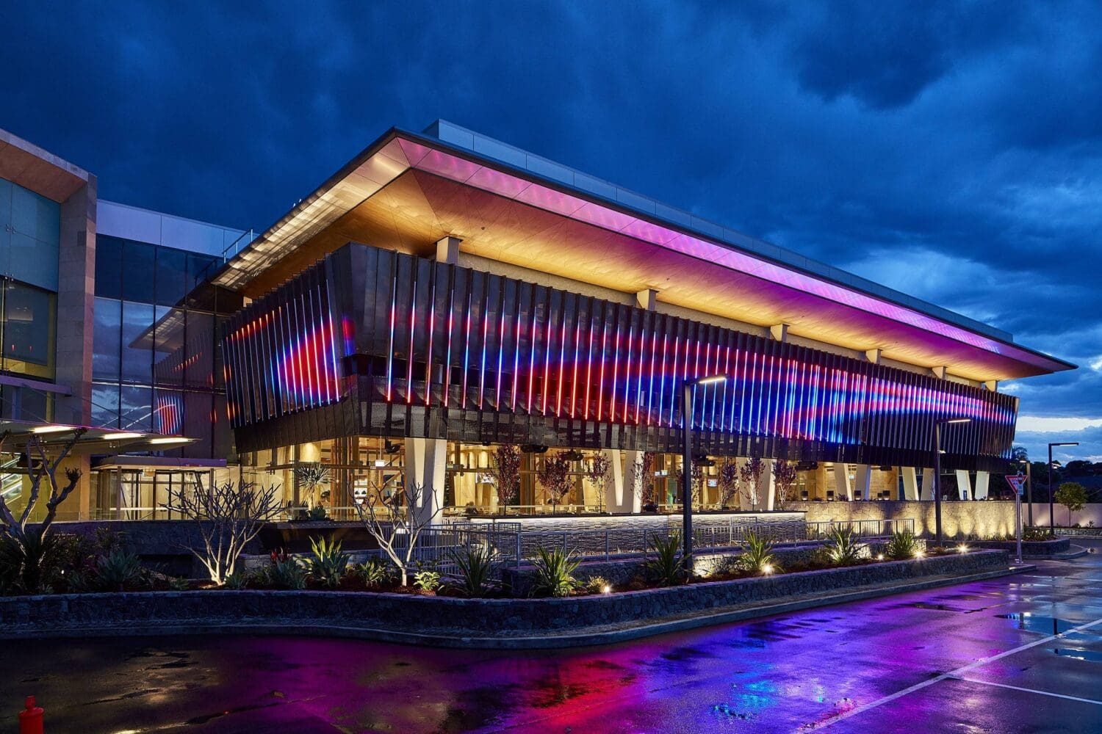

Discover Canterbury League Club – Dining, Events & Community All in One Place
If you’re searching for a place that blends community spirit, great food, entertainment, and a vibrant social atmosphere, then Canterbury League Club is one destination that truly delivers. Proudly serving South-West Sydney from its Belmore home since 1957, Canterbury League Club has evolved into much more than a local club — it’s a welcoming hub for everyone to eat, relax, celebrate and make memories.

A Warm Welcome for All
Right from the moment you arrive, you’ll notice Canterbury’s motto comes to life: “Everyone is welcome at Canterbury.” Whether you’re dropping in with family, meeting friends, cheering on a game, or enjoying a solo night out, the club’s inclusive vibe and friendly atmosphere make visitors feel instantly at ease.

What’s On: Fun, Food and Festivities
One of the best things about Canterbury League Club is that there’s always something happening — from special celebrations and seasonal features to family-friendly events and culinary experiences. Here’s a snapshot of what’s on:

🎉 Seasonal Specials & Offers
- Buy 1 Activity, Get the 2nd Half Price – Double the fun and savings for active fun lovers.
- Kids Eat Free at SendIt! – A perfect invitation for families to dine together.
- Lunar New Year Banquet & Activities – Celebrate with special menus and cultural fun.
- Valentine’s Day Cocktail Specials – Sip something special with someone special.
- Future Bulldogs Programs – Get excited about upcoming sporting opportunities.
These are just a few of the rotating events and experiences that keep locals and visitors alike coming back for fresh and exciting moments all year round.

Delicious Dining Options for Every Palate
Canterbury League Club isn’t just about fun — it’s a food lover’s playground with diverse dining venues designed to satisfy every craving:
🍴 The Bistro – Classic favourites and hearty meals that feel like home.
☕ Bakehouse Café – A stylish cafe-lounge serving light meals and great coffee.
🔥 2 Smokin’ Arabs – Award-winning American-style BBQ with bold flavour.
🍜 The Dynasty – Elegant dining with an Asian-inspired twist.
🍸 Bartega Cocktail Bar – Artisanal drinks, live music and warm ambience.
🍻 The Atrium Bar – Chill out with friends surrounded by greenery and relaxed vibes.
📺 Bulldogs Sports Bar – Great for live sport, big screens and cheering crowds.
Whether you’re after a casual coffee, a delicious dinner, or a night of cocktails and laughs, Canterbury’s dining lineup delivers something special for every taste.

More Than Just Good Times — It’s a Destination
Beyond events and dining, Canterbury League Club is packed with facilities that make every visit worthwhile:
- Live entertainment & shows — from bands to solo performers.
- Event spaces for celebrations — perfect for weddings, birthdays, corporate functions and more.
- On-site health & fitness gym (C-Life Health Club) — stay active and feel great.
- Ample parking + EV chargers — convenience for all guests.
These features combine to make Canterbury a true community centre, where every visit feels like a chance to reconnect with friends and family or discover something new.

Why Canterbury League Club Stands Out
Whether you live nearby or are planning a visit to Belmore, Canterbury League Club’s blend of community spirit, vibrant events, delicious food, and welcoming atmosphere makes it a standout destination. It champions the idea that good times are better when shared — and there’s always a place here for you.
Come for the food. Stay for the fun. Belong at Canterbury.
Contact Us
Address: 26 Bridge Rd, Belmore NSW 2192 Australia
Phone: 02 9704 7777
Email: info@canterbury.com.au
Website: https://canterbury.com.au/

