Get Telegram Accounts From Kycitshop.com
If you’re looking to Get Telegram Accounts from Kycitshop.com, you’re in the right place. Kycitshop provides high-quality Telegram accounts at a cheap rate, giving you the best value for your needs.
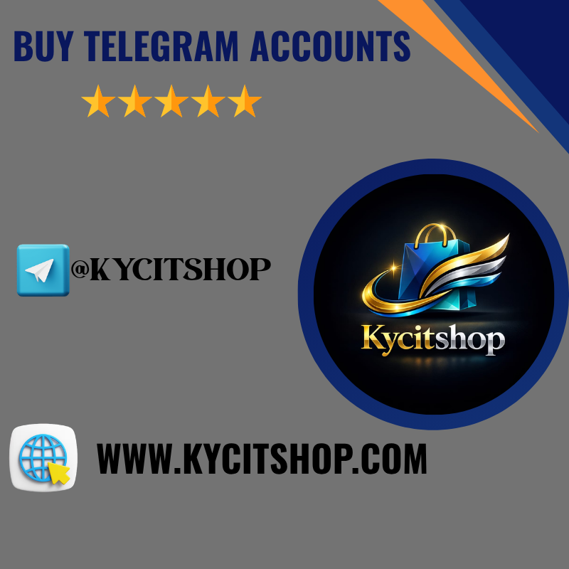
The Get Telegram Accounts from Kycitshop.com service includes verified, ready-to-use accounts that are perfect for marketing, business, or personal use. You can easily Get Telegram Accounts from Kycitshop.com and start using them instantly without any complex setup.
Whether you need accounts for bulk use or quick access, Get Telegram Accounts from Kycitshop.com ensures reliability, security, and smooth performance.

How to Get Telegram Accounts Safely in 2026
Getting Telegram accounts safely in 2026 is very important because security rules are stronger than before and many accounts can be blocked if not handled properly. When you try to get Telegram accounts, you should always focus on trusted and clean sources so the accounts stay active for a long time. It is also important to make sure each account has proper verification and does not have any previous misuse history.
At the same time, you should use a stable internet connection and avoid logging in from many devices or locations quickly, because this can create risk. Keeping account information private and using strong security settings will help protect access. If you follow safe methods and stay careful with usage, you can manage Telegram accounts easily without facing problems in the future.

Step-by-Step Guide to Get Telegram Accounts Quickly
Getting Telegram accounts quickly in 2026 is possible when you follow a clear and simple process without rushing in the wrong way. First, you need to choose a reliable source that provides clean and ready-to-use accounts so you do not face issues later. It is important to check that the accounts are properly verified and active, because this helps you start using them immediately without delay.
After that, you should access the accounts using a stable internet connection and avoid sudden changes in location or device, as this can create security alerts. Keeping the login process smooth and natural will help the accounts stay safe while saving your time. When you follow a proper step-by-step method with attention and care, you can get Telegram accounts quickly and use them without unnecessary problems.

Best Methods to Get Telegram Accounts Without Risk
Getting Telegram accounts without risk in 2026 requires a careful and smart approach, especially because platform security is now more advanced. The best method is to choose reliable and trusted sources that provide clean, verified, and unused accounts, so you can avoid future restrictions or sudden bans. It is also important to make sure the accounts have no previous suspicious activity, as this helps maintain long-term stability.
Using a consistent device and a stable internet connection can reduce the chance of triggering security warnings. You should avoid making fast or unusual changes right after accessing the accounts, because this can look unnatural to the system. When you follow safe practices and stay patient with the process, you can get Telegram accounts without risk and manage them smoothly for your needs.

Why Businesses Need to Get Telegram Accounts for Growth
Businesses today choose to get Telegram accounts because it helps them connect with a large and active audience in a simple and fast way. Telegram allows direct communication, which makes it easier to share updates, promotions, and important messages without delay. When businesses get Telegram accounts, they can build strong relationships with customers and create a trusted communication channel.
It also helps in marketing because messages can reach many people at once without high cost, making it useful for both small and large businesses. With proper use, businesses can increase engagement, improve brand visibility, and grow their audience over time. This is why many companies see Telegram as an important tool for steady and long-term growth.
📍Telegram :@kycitshop
📍Whatsapp :+1 (417) 559-8212
📍Web:https://kycitshop.com

Why Users Choose Get Telegram Accounts
A properly prepared Telegram account unlocks powerful opportunities for communication, marketing, and global reach:
🌍 Worldwide Connectivity – Instantly connect with users across different countries
💬 Direct & Fast Communication – Send messages, media, and updates without delays
📢 Channel & Group Growth – Build and manage large audiences easily
⏱️ Quick Start Access – Begin using without complex setup processes
🔐 Secure & Private Usage – Enjoy strong privacy features and account stability

What Kycitshop Offers for Get Telegram Accounts
Kycitshop delivers expert solutions to help you use Telegram accounts efficiently and without hassle:
✔️ Step-by-step assistance for Get Telegram Accounts setup
✔️ Verified and ready-to-use account guidance
✔️ Support for personal, marketing, and business usage
✔️ Tips to grow Telegram channels and groups faster
✔️ Security guidelines to keep accounts safe and active
✔️ Bulk account solutions for scaling projects
✔️ Fast and reliable delivery with ongoing support

What is the secret chat feature on Telegram?
Telegram’s secret chat feature offers a layer of privacy that many users appreciate. This option allows for end-to-end encryption, meaning only you and the recipient can read the messages. In these chats, even Telegram itself cannot access your conversations. Each message is self-destructing, which means it disappears after a set time. You can customize this timer based on your preferences.
Another intriguing aspect is that secret chats are device-specific. If you start a secret chat on one device, it won’t appear on another. This ensures added security and peace of mind. Additionally, screenshots are not allowed in secret chats; if someone tries to capture the screen, you’ll be notified immediately. It’s an ideal way to communicate sensitive information without worrying about prying eyes or unwanted access.

Why People Prefer to Buy Telegram Accounts
People are increasingly turning to buy Telegram accounts for various reasons. One primary motivation is the desire for anonymity. With growing concerns about privacy, many users appreciate Telegram’s focus on secure messaging. Another reason is community access. Buying an established account can grant entry into exclusive groups or channels, which might be difficult for newcomers to join organically.
For businesses and marketers, ready-made accounts save time. They can tap into existing followers and engage with a targeted audience instantly. Additionally, some users seek specialized content that aligns with their interests or business needs. An active Telegram account provides a platform to connect with like-minded individuals quickly.
There’s the appeal of convenience. Purchasing an account allows users to bypass lengthy sign-up processes while immediately gaining credibility in their chosen niche or market.

Why Buy Telegram Accounts Is a Smart Choice
Buy Telegram accounts can be a strategic move for various reasons. With the platform’s surge in popularity, having an established account opens doors to countless opportunities. A ready-made account comes with followers, engagement, and credibility. This instantly saves time that would otherwise be spent on building from scratch. Businesses often seek this advantage to enhance their outreach quickly.
Moreover, the anonymity of purchasing accounts enables users to dive into niche markets without hesitation. Whether promoting products or services, owning a buy verified Telegram account can lend authority and trustworthiness. Additionally, many users appreciate flexibility when managing multiple accounts for different purposes—be it marketing campaigns or personal interests. By investing in pre-existing accounts, you gain instant access to diverse communities and discussions that align with your goals.

How to Buy Telegram Accounts Safely
When it comes to buy Telegram accounts, safety should be your top priority. Start by researching reputable sellers online. Look for reviews and testimonials that can give you insight into their reliability. Always communicate directly with the seller before making a purchase. Ask questions about the account’s history and usage to gauge its authenticity. A trustworthy seller will provide clear answers.
Use secure payment methods whenever possible. This adds an extra layer of protection for your transaction. Avoid using untraceable payment options like cryptocurrency unless you fully trust the vendor. After purchasing, change the password immediately to ensure only you have access. Additionally, enable two-factor authentication on your new Telegram account for enhanced security.
Stay vigilant against scams by being cautious of deals that seem too good to be true. Protecting yourself during this process is key to enjoying all the benefits a new Telegram account can offer.


How to Quickly Get Telegram Accounts for Personal Use
Getting Telegram accounts for personal use is simple if you follow the right steps and use trusted methods. First, you need a valid mobile number because Telegram sends a verification code to confirm your account. This number can be your own or a safe virtual number from a reliable service. After entering the code, your account becomes active in just a few minutes. Telegram works smoothly on both mobile and desktop, so you can choose the device that is easiest for you. Once logged in, you can add a profile photo, set your name, and adjust privacy settings to feel more secure. Always avoid fake or unsafe sources, because they can cause account problems later. Using a clean and verified setup helps you enjoy Telegram safely for chatting, groups, and personal communication.

Top Methods to Safely Get Telegram Accounts Online
Getting Telegram accounts online can be safe and easy when you choose the correct and trusted way. Many people prefer online methods because they save time and give quick access. It is important to use real phone numbers or secure virtual numbers from reliable providers to receive the verification code without issues. After verification, the account becomes ready to use within minutes. Always check privacy settings to protect your personal information from unknown users. Avoid free or suspicious offers, as they can lead to account bans or security risks. A safe method ensures long-term use, smooth messaging, and full access to Telegram features.

Why You Should Consider Trusted Sources to Get Telegram Accounts
Choosing trusted sources to get Telegram accounts is very important for long-term safety and smooth use. Reliable sources provide properly verified accounts that work without sudden login problems or blocks. When you use trusted services, your account stays more secure and your personal data remains protected. Untrusted or cheap sources often sell low-quality accounts that can be banned at any time. A trusted source also helps you avoid spam issues and limits set by Telegram. This makes your experience better for personal chats, groups, and daily communication. Using safe and trusted options gives peace of mind and saves you from future trouble.
Step-by-Step Guide to Get Telegram Accounts Easily
Getting Telegram accounts easily is possible when you follow a simple and clear process. First, you need access to a valid phone number so Telegram can send a verification code. After installing the Telegram app, enter the number carefully and wait for the code to arrive. Once you submit the code, your account is activated instantly without long delays. You can then set your profile name and photo to make the account look real and personal. Adjust privacy and security settings to keep your account safe from unknown contacts. Using a clean setup helps the account stay stable and ready for daily personal use.
Benefits of Choosing Verified Ways to Get Telegram Accounts
Choosing verified ways to get Telegram accounts gives you better safety and long‑term use without stress.
Verified methods help you avoid sudden bans and login problems that often come from unsafe sources.
When an account is properly verified, it works smoothly for personal chats and joining groups.
Your personal data stays more secure because trusted methods follow Telegram rules.
You also get better account stability, so you do not need to create new accounts again and again.
Using verified ways saves time, reduces risk, and gives you peace of mind while using Telegram daily.

How to Get Telegram Accounts Without Any Hassle
Getting Telegram accounts without any hassle is easy when you follow a clean and simple process.
Use a valid phone number so the verification code arrives quickly without problems.
Install the official Telegram app and complete the login steps carefully to avoid errors.
After activation, update your profile details to make the account look natural and real.
Check privacy and security settings to protect your account from unknown access.
Avoid unsafe or free sources, as they often create issues later.
A smooth and verified setup helps you enjoy Telegram comfortably for personal use.

Common Mistakes to Avoid When You Get Telegram Accounts
When getting Telegram accounts, avoiding common mistakes can save you time and trouble.
Using fake or unreliable phone numbers is risky because the account may be blocked or lost.
Relying on free or suspicious sources often leads to accounts that stop working suddenly.
Skipping privacy and security settings can expose your personal information to strangers.
Sharing verification codes or account details with others creates security problems.
Not updating your profile properly may make the account appear suspicious to Telegram.
By being careful and following trusted steps, you can keep your Telegram account safe and fully functional.

Why Businesses Get Telegram Accounts for Marketing Growth
Businesses todayare increasingly turning to Telegram as a powerful tool for marketing growth because it combines direct communication with wide-reaching visibility. Unlike traditional social media,
Telegram allows companies to create channels and groups where they can share updates, promotions, and exclusive content directly with their audience,
building a more personal connection. Its focus on privacy and ad-free experience makes users more receptive to messages, which helps businesses establish trust and credibility. With features like polls, bots, and multimedia messaging,
companies can engage their audience creatively, making marketing campaigns more interactive and memorable. Telegram also supports global reach, enabling brands to connect with international customers without language barriers through translation tools.
The platform’s speedand security ensure that messages are delivered instantly, maintaining the relevance and timeliness of marketing efforts. By leveraging Telegram’s unique ecosystem, businesses can nurture communities, drive engagement, and ultimately convert followers into loyal customers, all while standing out from competitors who rely solely on mainstream social media.
If you want, I can also make aneven more simplified and universally understandable versionso people from non-English countries can grasp it easily. Do you want me to do that?
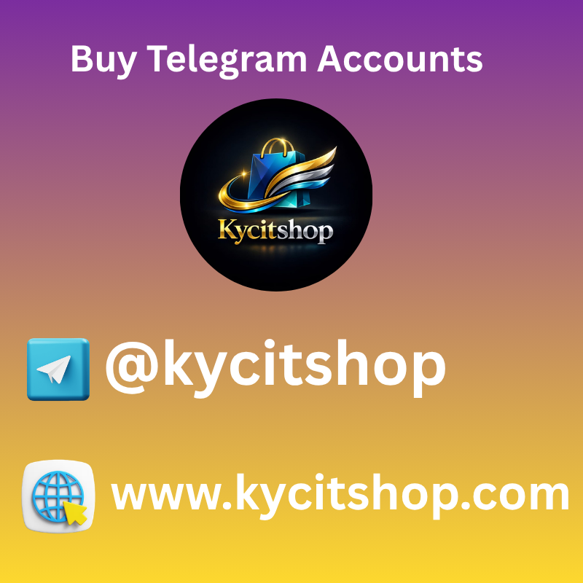

How to Safely Get Telegram Accounts Without Risks
Getting Telegram accountssafely means always choosing legal and transparent methods. The safest way is to create an account using your own valid mobile number and follow Telegram’s official verification process. Avoid buying accounts from unknown sellers or online marketplaces, as these accounts may be stolen, fake, or already flagged for suspicious activity. Using unofficial methods can lead to permanent bans, data loss, or privacy risks.
If you need multiple accounts for business or marketing, make sure you comply with Telegram’s terms of service and local regulations. Protect your account by enabling two-step verification and never sharing login codes with anyone. Be cautious of websites or apps that promise instant accounts, as many are scams designed to steal personal information. Staying within official guidelines is the only reliable way to use Telegram without security or legal risks.

Best Platforms to Get Telegram Accounts Instantly
Here are some of the best platforms where you can getTelegram accountsinstantly that people from any country can easily understand and use.
These services are known for providing quick and reliable account creation so you do not have to wait or struggle with complicated steps.
They offer verified or ready‑to‑use Telegram accounts that you can access right away, which saves you time and effort when you need multiple accounts or want to start quickly. Most of these platforms work globally and support users who speak different languages,
making them easyfor everyone to navigate. With user‑friendly interfaces and simple instructions, even beginners can find and choose the right Telegram account package for their needs. By using these platforms,
you can skip the lengthy sign‑up process and start chatting, joining groups, or managing channels without delay. Remember to always choose trusted and secure sites to protect your privacy and account safety. This helps you get your Telegram accounts instantly while staying safe online.

Things to Check Before You Get Telegram Accounts Online
Before purchasinga Telegram account online, it’s crucial to approach with caution and awareness. Not all sellers are reliable, and some accounts may have hidden restrictions or could even be flagged for suspicious activity.
Verifying the account’s age and activity level can help ensure it’s genuine and won’t be banned shortly after use. Understanding the security features, such as two-step verification and linked phone numbers, is essential to avoid potential hacking risks.
It’s also wise to check whether the account comes with any existing subscriptions or channels, as these can affect your experience. Paying attention to the source’s reputation and reading reviews can save you from scams.
Being aware of regional restrictions and privacy settings will help you manage the account safely. Taking these precautions not only protects your personal data but also ensures a smoother, uninterrupted Telegram experience.
If you want, I can also rewrite it to be even morecatchy and persuasive, making it feel like expert advice for anyone globally. Do you want me to do that?

Benefits You Unlock When You Get Telegram Accounts
Getting a Telegram accountopens up a world of possibilities that go beyond simple messaging. It allows you to connect with friends, family, and communities from around the globe instantly, without worrying about borders or expensive charges.
You can join groups and channels that match your interests, from technology updates to lifestyle tips, making it easy to stay informed and entertained. Telegram also values privacy and security, giving you control over who sees your messages and personal information.
The platform supports sharing large files, multimedia, and documents, which makes collaboration smooth and efficient. Using Telegram, you can communicate freely with people who speak different languages thanks to built-in translation tools.
The app’s cloud-based system ensures that your chats are accessible across devices anytime you need them. With constant updates and new features, Telegram keeps your communication modern, flexible, and enjoyable.
If you want, I can make aneven simpler versionthat is extremely easy for people from any non-English country to understand. Do you want me to do that?

Affordable Ways to Get Telegram Accounts in Bulk
Affordable ways toget Telegram accountsin bulk should always focus on legal and ethical methods rather than risky shortcuts. The safest approach is to create accounts through official channels or use verified business solutions that follow Telegram’s terms of service.
This protects your brand, your data, and your long term growth without the danger of sudden bans or account losses.
Many marketing agencies and automation platforms offer compliant account management services that help businesses scale responsibly. Instead of purchasing unknown bulk accounts from unreliable sources,
investing in transparent providers ensures better security, real user engagement, and stable performance. Choosing legitimate options may seem slower at first, but it builds trust and sustainable results over time.

Common Mistakes to Avoid When You Get Telegram Accounts
Avoiding these pitfalls will help you maintain a long-term presence on the platform.Atkycsiteprovides high quality accounts at cheap rate to help you start your marketing journey without the usual technical headaches.

Critical Security Errors
- Logging in without a Proxy:Telegram tracks IP addresses; using a fresh account on a flagged IP leads to instant termination.
- Changing Details Too Fast:Rapidly updating the profile name, bio, and photo triggers spam filters.
- Neglecting Two-Factor Authentication:Always enable 2FA immediately after youGet Telegram Accountsto prevent original owners or hackers from regaining access.

Get Telegram Accounts for Easy Global Communication
In today’s fast-moving digital world, Telegram has become one of the most trusted messaging platforms for people across non-English countries. With strong privacy features and smooth performance, it allows users to connect globally without language barriers. Many individuals and businesses now prefer Telegram to communicate with international audiences easily and securely. Choosing the right source to manage accounts plays a major role in achieving stable and long-term communication success.

Meta Insight: Why Telegram Matters Worldwide
Telegram is widely used because it works well even with low internet speed and supports multiple languages. This makes it ideal for users from different regions who want simple and reliable communication. When users Get Telegram Accounts, they unlock the ability to join global groups, share content instantly, and interact without complex setup processes.

Sub-Category: Trusted Account Quality
At Kycitshop, the focus is on delivering high-quality Telegram accounts at a cheap rate. These accounts are carefully prepared to ensure smooth usage and long-term reliability. When people Get Telegram Accounts from a trusted provider, they reduce the risk of account issues and enjoy better performance for both personal and business needs.

Meta Title Focus: Benefits of Using Telegram Accounts
Telegram accounts help users expand their digital reach beyond borders. Whether for marketing, community building, or private conversations, the platform supports fast growth and engagement. Many users Get Telegram Accounts to build credibility and connect with audiences in different countries without restrictions.
Key advantages include:
- High security and privacy protection
- Fast messaging and media sharing
- Support for large groups and channels
- Easy access for non-English users
✨🍁✨🍁✨🍁✨🍁✨🍁✨🍁✨🍁✨🍁✨🍁✨🍁✨🍁✨🍁🍁🍁
🚀Contact us For Instant Support-
✅Telegram : @Kycitshop
✅Whatsapp : +1 (417) 559-8212
✅Telegram : @Kycitshop
✅Telegram : @Kycitshop
✅Whatsapp : +1 (417) 559-8212
✅Whatsapp : +1 (417) 559-8212
✨🍁✨🍁✨🍁✨🍁✨🍁✨🍁✨🍁✨🍁✨🍁✨🍁✨🍁✨🍁🍁🍁

Sub-Category: Business and Personal Growth
For businesses, Telegram is a powerful tool to connect with customers worldwide. Entrepreneurs Get Telegram Accounts to promote services, manage communities, and maintain direct contact with clients. Personal users also benefit by staying connected with friends and groups globally in a simple and user-friendly way.

Final Meta Insight: Smart Choice for Global Reach
Choosing the right provider is essential when planning to expand communication channels. With affordable pricing and dependable service, Kycitshop helps users Get Telegram Accounts that are ready for immediate use. This approach saves time, reduces effort, and ensures smooth global communication for everyone.

Get Telegram Accounts to Reach International Audiences Faster
In the modern digital space, reaching people across borders has become easier with messaging platforms like Telegram. It is widely used in non-English countries because of its speed, security, and language-friendly interface. Many brands and individuals now rely on Telegram to expand their global presence quickly. When users Get Telegram Accounts [1], they gain instant access to international communities without complex technical barriers.

Meta Title Insight: Power of Telegram for Global Reach
Telegram allows users to communicate with audiences from different regions in real time. Its lightweight design works smoothly even in areas with slow internet connections. This is why marketers, content creators, and online businesses Get Telegram Accounts [2] to connect with global users faster and more effectively.

Sub-Category: High-Quality Accounts You Can Trust
At Kycitshop, the main priority is quality and affordability. The platform provides high quality accounts at cheap rate, making it easier for users to start without heavy investment. Reliable accounts reduce the risk of bans and interruptions, which is essential when targeting international audiences. Many professionals Get Telegram Accounts [3] from trusted providers to ensure long-term stability.

Get Telegram Accounts Instantly Online
The demand to Get Telegram Accounts instantly online continues to grow as Telegram becomes more popular for communication and community building. Quick access to accounts allows users to start messaging, joining groups, and connecting with others without waiting.
A trusted platform can make the process easy and convenient. Many users turn to Kycitshop.com for fast access to Telegram accounts that are prepared for immediate use. This helps users begin their Telegram activities smoothly and without complications.
Instant access also helps individuals and businesses stay productive. When you Get Telegram Accounts online, you can quickly participate in discussions, build communities, and expand your presence on the platform.

Get Telegram Accounts for Fast Growth
Telegram has become an important platform for communities, influencers, and businesses. Many users decide to Get Telegram Accounts to accelerate their growth and reach more people in less time.
Having multiple accounts allows better engagement across groups, channels, and conversations. It helps users stay active and maintain strong communication with their audiences.
Platforms like Kycitshop.com support users by providing reliable Telegram accounts that help simplify the process. This allows users to focus on growing their network, sharing valuable content, and building strong online communities.
When you Get Telegram Accounts with the right preparation, achieving faster growth on Telegram becomes much easier and more efficient.

Get Telegram Accounts for Channels & Groups
Telegram channels and groups are powerful tools for communication and community management. Many administrators choose to Get Telegram Accounts to manage multiple channels and participate in different groups effectively.
Having additional accounts allows smoother management of discussions, content sharing, and audience interaction. It also helps administrators organize communities and maintain active engagement.
A reliable platform like Kycitshop.com makes it simple to access Telegram accounts that can support these activities. With properly prepared accounts, managing channels and groups becomes more efficient.
When you Get Telegram Accounts for channels and groups, you can expand your community and maintain consistent communication with your members.

Get Telegram Accounts for Personal Use
Telegram is widely used for personal communication, networking, and staying connected with friends and family. Many people choose to Get Telegram Accounts to enjoy flexible communication options.
Additional accounts can help users separate different conversations, manage contacts, or join various communities comfortably. Telegram’s features make personal communication smooth and convenient.
For users looking for a reliable solution, Kycitshop.com provides Telegram accounts designed to support personal use. This allows individuals to access Telegram easily and maintain their connections.
When you Get Telegram Accounts for personal use, it becomes easier to organize chats, explore communities, and enjoy a seamless messaging experience.

Get Telegram Accounts for Business Marketing
Telegram has become a valuable platform for business marketing and communication. Many companies decide to Get Telegram Accounts to expand their marketing activities and interact with audiences effectively.
Using multiple accounts allows businesses to manage communities, share updates, and engage with customers more efficiently. Telegram channels and groups help businesses build strong relationships with their audience.
Businesses often rely on Kycitshop.com to obtain Telegram accounts prepared for smooth usage. This helps marketing teams focus on promoting their services and connecting with more people.
When you Get Telegram Accounts for business marketing, you create more opportunities to grow your brand and strengthen customer engagement.

Get Telegram Accounts to Expand Community
Building a strong community on Telegram requires active participation and consistent communication. Many community builders choose to Get Telegram Accounts to expand their reach and support community activities.
Multiple accounts help moderators and administrators manage discussions, share information, and maintain engagement within the community. This helps create a more active and welcoming environment. Get Telegram Accounts.
Platforms like Kycitshop.com make it easy for users to access Telegram accounts that support community growth. This allows community leaders to focus on building meaningful interactions.
When you Get Telegram Accounts to expand your community, you strengthen connections and create a vibrant space for members.

Get Telegram Accounts for Influencer Growth
Influencers and content creators are increasingly using Telegram to connect with their audience. Many choose to Get Telegram Accounts to support their growth and maintain strong communication with followers.
Telegram channels allow influencers to share updates, announcements, and exclusive content with their community. Additional accounts help them manage engagement more effectively.
With support from Kycitshop.com, influencers can access Telegram accounts that make their workflow easier. This allows creators to focus on content creation and audience interaction.
When influencers Get Telegram Accounts, they can expand their reach and build stronger relationships with their followers.

Buy Telegram Accounts – Verified & Ready
Buying Telegram accounts is an effective way to grow your online presence and connect with a wider audience instantly. Kycitshop provides fully verified Telegram accounts that are ready to use immediately, ensuring a secure and reliable experience.
These accounts save time on creating and verifying new profiles, allowing users to focus on managing channels, groups, and communities efficiently. With Kycitshop, you gain access to accounts offering credibility, reliability, and uninterrupted usage.
Verified Telegram accounts are perfect for individuals, businesses, and influencers looking to establish a strong presence while maintaining trust and professionalism.

Buying Telegram Accounts Instantly Online
Buy Telegram accounts from Kycitshop are available for instant purchase online, allowing users to start using them without delays. Immediate access helps individuals and businesses engage with their communities efficiently.
Kycitshop ensures that all accounts are verified, secure, and reliable, making the buying process safe and hassle-free. Users can focus on building channels, managing groups, and interacting with followers without worrying about restrictions or verification issues.
Purchasing accounts from Kycitshop guarantees convenience, speed, and trustworthiness for every user.

Buy Telegram Accounts for Fast Growth
Using Buy Telegram accounts from Kycitshop accelerates growth on the platform. These accounts provide credibility and allow users to expand their reach quickly by managing channels, joining groups, and engaging with a larger audience.
Buy Telegram accounts save time and give instant access to all Telegram features, enabling users to focus on growth strategies. Kycitshop ensures accounts are fully secure, reliable, and ready for immediate use, making it easier to build strong communities or promote content effectively.

Buying Telegram Accounts for Channels & Groups
Buy Telegram accounts are ideal for managing channels and groups efficiently. They allow users to post content, engage with members, and grow communities without restrictions.
Businesses and individuals can enhance visibility, increase interaction, and expand their audience effectively using Kycitshop accounts. All accounts are secure, ready to use, and reliable for personal and professional purposes, ensuring smooth management of channels and groups while fostering engagement.

Buy Telegram Accounts for Personal Use
Buy Telegram accounts from Kycitshop are perfect for personal use. Individuals can connect with friends, participate in groups, and share content effortlessly.
These accounts provide credibility, secure access, and immediate functionality, saving time on registration and verification. Using Kycitshop ensures a professional, uninterrupted, and safe personal Telegram experience. Verified accounts offer a reliable foundation for personal communication, networking, and community engagement.

