Buy Aged Gmail Accounts with Confidence
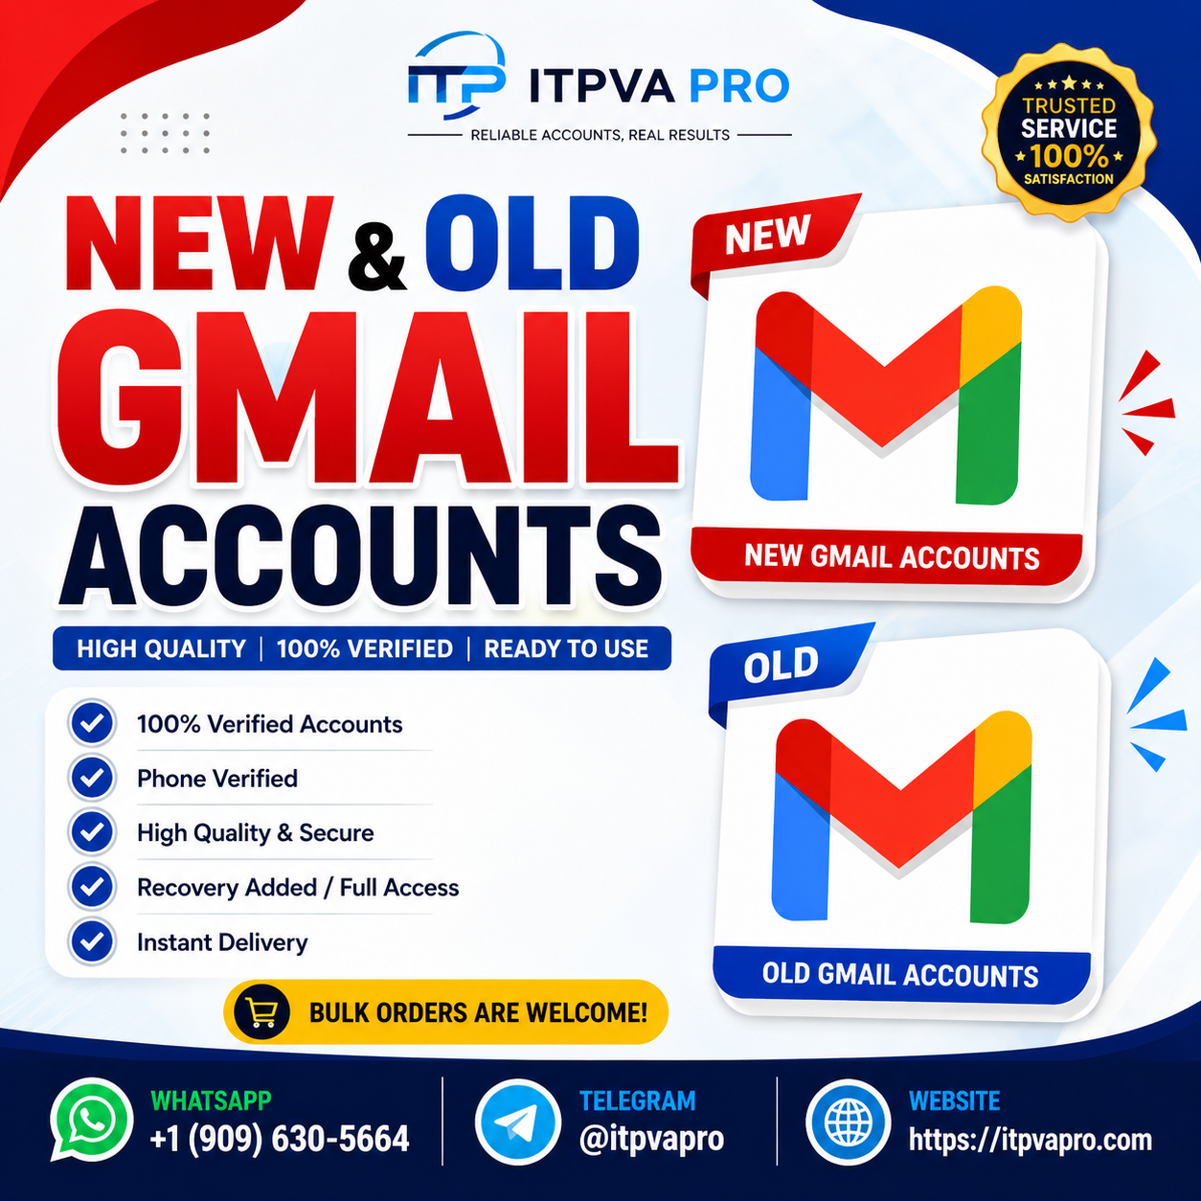
In the modern digital landscape, email accounts are more than simple communication tools. They serve as gateways to business operations, marketing platforms, social networks, cloud services, and professional communication. Among all email providers, Gmail remains one of the most widely trusted and recognized platforms worldwide.
As digital needs continue to grow, many users look for aged Gmail accounts because of their stability, history, and immediate usability. Whether for business operations, account management, or workflow efficiency, aged Gmail accounts have become increasingly relevant in many online environments.
This guide explores what aged Gmail accounts are, why people seek them, their potential benefits, and the key factors to consider before making a decision.
☎️ Contact ☎️
⇨➤~Telegram: @itpvapro
⇨➤~WhatsApp :+1 (909) 630-5664
⇨➤~Email : itpvapro@gmail.com
⇨➤~ https://itpvapro.com/product/buy-old-gmail-accounts

What Are Aged Gmail Accounts?
Aged Gmail accounts are Gmail accounts that were created months or even years ago and have existed over a longer period compared to newly created accounts.
The primary difference between fresh and aged accounts is time. Older accounts often have account history, login records, and an established digital presence. In many situations, account age can influence how trusted an account appears on different platforms.
Because of this, aged Gmail accounts are often seen as more established than newly created ones.

Why People Prefer Aged Gmail Accounts
There are several reasons why users prefer aged Gmail accounts over fresh ones.

Established Account History
Older accounts usually have more account history. This makes them appear more natural in digital environments where account reputation matters.

Immediate Usability
New accounts sometimes require additional setup, verification, and warming-up periods. Aged accounts can often be used more quickly for intended workflows.

Increased Stability
Long-standing accounts may offer better reliability for users managing multiple tools, projects, or online platforms.
These factors make aged Gmail accounts attractive for users who need efficient and reliable email access.
☎️ Contact ☎️
⇨➤~Telegram: @itpvapro
⇨➤~WhatsApp :+1 (909) 630-5664
⇨➤~Email : itpvapro@gmail.com
⇨➤~ https://itpvapro.com/product/buy-old-gmail-accounts

Common Uses of Aged Gmail Accounts
Aged Gmail accounts serve many practical purposes across different industries and workflows.

Business Communication
Companies often need reliable email accounts for communication with clients, vendors, and team members. Established Gmail accounts can support smoother communication.

Digital Marketing Workflows
Marketers frequently rely on email accounts to manage campaigns, tools, and connected platforms. Stable accounts help support daily operations.

Backup and Recovery
Some users maintain additional Gmail accounts for recovery, security backup, or secondary account management.

Testing and Development
Developers and technical teams often use multiple accounts for testing applications, reviewing systems, or managing workflow experiments.
Because email accounts connect to so many services, reliable access matters.

Benefits of Choosing Aged Accounts
Understanding the practical advantages of aged Gmail accounts can help users make informed decisions.

Faster Setup
Since aged accounts already exist, users often spend less time on initial setup and preparation.
☎️ Contact ☎️
⇨➤~Telegram: @itpvapro
⇨➤~WhatsApp :+1 (909) 630-5664
⇨➤~Email : itpvapro@gmail.com
⇨➤~ https://itpvapro.com/product/buy-old-gmail-accounts

Better Trust Signals
Older accounts may carry stronger trust signals in systems that evaluate account maturity and history.

Improved Workflow Efficiency
Users working with multiple platforms often benefit from accounts that are ready for immediate use.
These benefits can save time and improve productivity in fast-moving digital environments.

Important Factors to Consider Before Buying
Choosing aged Gmail accounts requires careful consideration. Not all accounts offer the same quality or reliability.

Account Security
Security should always come first. Make sure the account allows full access and secure credential updates.
Important steps include:
- Changing the password immediately
- Updating recovery information
- Enabling two-factor authentication
- Monitoring account login activity
Good security practices help protect long-term account access.

Account Quality
Not all aged accounts are equally reliable. A healthy account should have a clean history and normal usage patterns.
Accounts with suspicious activity may create risks later.
☎️ Contact ☎️
⇨➤~Telegram: @itpvapro
⇨➤~WhatsApp :+1 (909) 630-5664
⇨➤~Email : itpvapro@gmail.com
⇨➤~ https://itpvapro.com/product/buy-old-gmail-accounts

Intended Use
Clearly define why you need the account.
For example:
- Professional communication
- Marketing tools
- Testing purposes
- Backup systems
Understanding the purpose helps ensure you choose the right account type.

Best Practices After Accessing an Aged Gmail Account
Once you gain access to an aged Gmail account, proper management becomes essential.

Update All Security Settings
This should be your first step. Secure the account fully before using it.

Maintain Consistent Usage
Normal, regular activity helps keep accounts healthy and stable.

Avoid Suspicious Behavior
Unusual login patterns, excessive activity, or rapid location changes may trigger security checks.
☎️ Contact ☎️
⇨➤~Telegram: @itpvapro
⇨➤~WhatsApp :+1 (909) 630-5664
⇨➤~Email : itpvapro@gmail.com
⇨➤~ https://itpvapro.com/product/buy-old-gmail-accounts

Keep Recovery Options Current
Always ensure recovery email and phone details remain updated.
Good account management significantly improves long-term reliability.

Why Confidence Matters
When dealing with digital assets like email accounts, confidence comes from knowledge and preparation. Understanding account age, account quality, security measures, and proper management reduces uncertainty.
The goal is not simply to access an account—it is to ensure that the account remains secure, functional, and useful over time.
Making informed decisions leads to better long-term outcomes.

Final Thoughts
Buying aged Gmail accounts with confidence starts with understanding what makes an account valuable. Age, history, usability, and security all play important roles in determining account quality.
Aged Gmail accounts can offer practical advantages for business communication, digital workflows, testing, and account management. Their established presence often provides benefits that newer accounts may not immediately offer.
However, long-term success depends on proper security, responsible usage, and careful account management. With the right approach, aged Gmail accounts can become valuable tools for modern digital operations.
☎️ Contact ☎️
⇨➤~Telegram: @itpvapro
⇨➤~WhatsApp :+1 (909) 630-5664
⇨➤~Email : itpvapro@gmail.com
⇨➤~ https://itpvapro.com/product/buy-old-gmail-accounts

