25 Top Quality Platforms to Buy SSN Number 2026
In today’s digital age, having access to a valid Social Security Number (SSN) is essential for a wide range of legal and financial activities. Whether you’re trying to establish a credit profile, apply for a loan, start a job, or open a bank account in the United States, an SSN is your gateway. At ReviewShopUSA, we understand the growing demand for fast, discreet, and authentic SSN services. That’s why we offer a reliable solution for those looking to buy SSN numbers safely and privately.
Do You Need SSN Numbe?
👉 just contact now.
✈️⇒Telegram: @ReviewShopUSA
📞⇒ WhatsApp: +1 (207) 613-6818
👉⇒Visit Now:https://reviewshopusa.net/product/buy-ssn-number

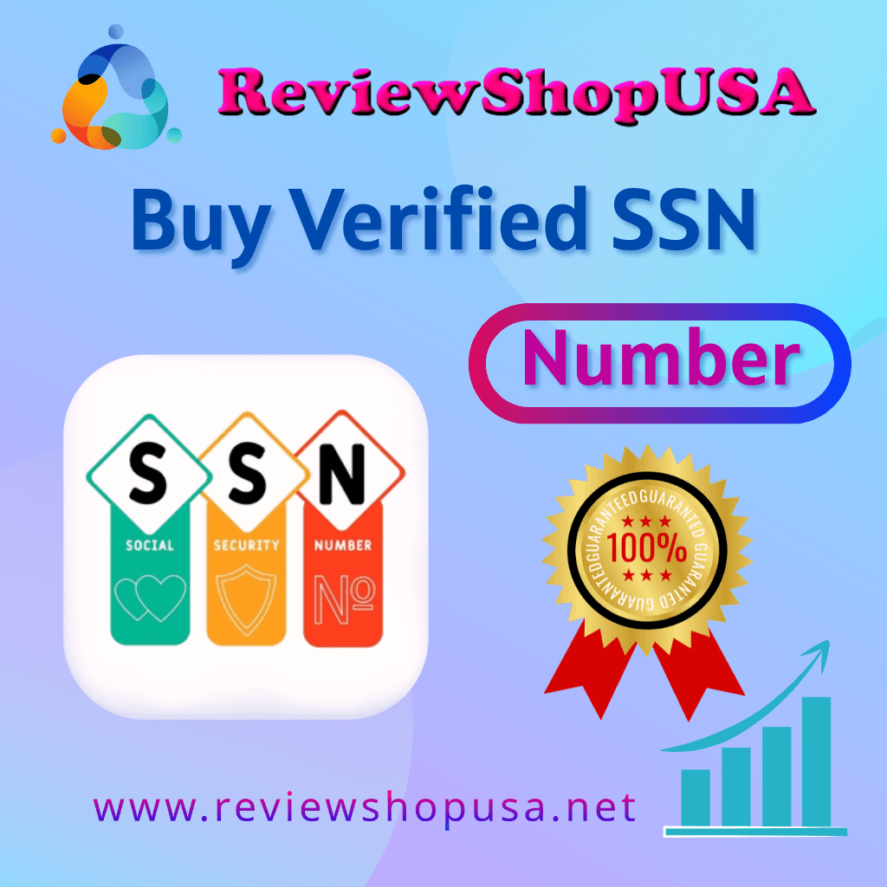
What Is an SSN and Why Is It Important?
A Social Security Number is a nine-digit identifier issued by the U.S. government to citizens, permanent residents, and eligible non-citizens. It serves as a personal tracking number for various official purposes — from paying taxes to securing employment, accessing medical services, and building credit. Without an SSN, navigating the American financial or legal system becomes nearly impossible.

That’s why it’s so important to have access to a valid and unique SSN, especially if you’re an expatriate, digital nomad, or international student trying to make a life in the U.S.

Who Might Need to Buy an SSN?
There are various scenarios where individuals find themselves needing access to a Social Security Number:

Newcomers to the U.S. who have yet to be issued their SSN and need one urgently for banking or employment.

Freelancers or business owners looking to register with payment platforms or credit bureaus.

People rebuilding their credit profile or starting fresh due to past issues.

Remote workers who are contracted by U.S.-based companies but reside abroad.

International students who need an SSN to meet university, banking, or housing requirements.

At ReviewShopUSA, we cater to all these unique needs by providing a fast, secure, and completely confidential process to buy an SSN number online.
Do You Need SSN Numbe?
👉 just contact now.
✈️⇒Telegram: @ReviewShopUSA
📞⇒ WhatsApp: +1 (207) 613-6818
👉⇒🚀Visit Now:https://reviewshopusa.net/product/buy-ssn-number

Why Choose ReviewShopUSA to Buy SSN?
We’re not just another online marketplace — we are a trusted name in identity services. Our commitment to privacy, customer support, and data protection makes us stand out. Here’s what you can expect when you choose ReviewShopUSA:

1. Genuine SSNs with Verified Records
All SSNs provided are verified, with matching background data and legitimate formatting. You can use them for financial applications, government forms, and identification processes.

2. Discreet and Secure Transactions
We use end-to-end encrypted communication and multiple secure payment gateways to ensure that your purchase remains private. Your data is never shared, stored, or compromised.

3. Fast Delivery and Easy Access
No more waiting weeks or months. Our streamlined process ensures you receive your SSN details quickly, with all relevant documentation, if applicable. In most cases, you’ll get your SSN within 24 to 72 hours.

4. Real Human Support
Confused about the process? Need guidance? Our customer support team is available 24/7 to help you every step of the way. You’re never alone when working with us.

5. Satisfaction Guaranteed
We stand by the quality of our service. If you’re not satisfied, our flexible policies and responsive team will make it right — because your trust matters to us.
peace of mind.

