The Evolution of Medical Scribing in the Digital Healthcare Era
Healthcare has undergone significant digital transformation over the past decade. Electronic health records (EHRs), telehealth, artificial intelligence (AI), and other digital technologies have changed how healthcare providers document patient information and deliver care. While these advancements have improved access to patient data and streamlined many clinical processes, they have also increased documentation responsibilities for physicians and other healthcare professionals. As a result, medical scribing has evolved into an important support function that helps healthcare providers manage clinical documentation more efficiently.
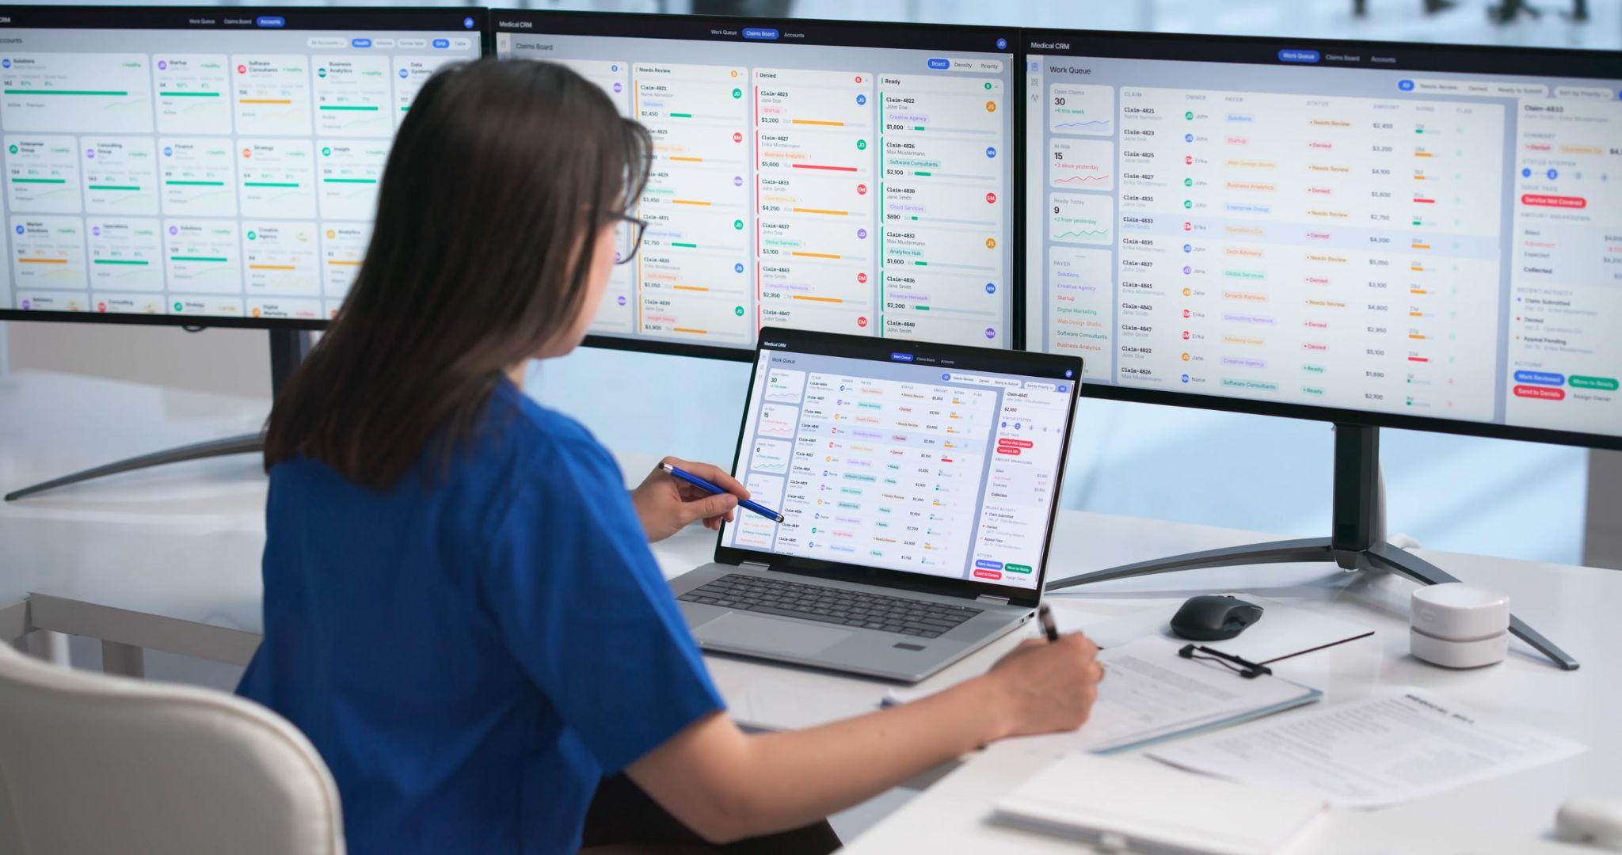
Medical scribing has progressed from traditional in-person note-taking to remote, virtual, and technology-assisted documentation models. Today, medical scribes work alongside healthcare providers to accurately document patient encounters while allowing clinicians to devote more attention to patient care.

Understanding Medical Scribing
Medical scribing is the process of documenting patient encounters in real time under the direction of a licensed healthcare provider. Medical scribes record clinical information, organize documentation within electronic health records, and help ensure patient records remain complete and accurate.
Rather than making clinical decisions, medical scribes focus on capturing information shared during patient visits. Their responsibilities often include documenting medical histories, physical examination findings, assessment details, treatment plans, and follow-up instructions as directed by the provider.
Accurate documentation supports continuity of care while creating complete medical records for future reference.

The Shift from Paper Records to Digital Documentation
Healthcare organizations once relied primarily on handwritten patient records. Although paper charts served their purpose, they often presented challenges related to storage, accessibility, and information sharing.
The widespread adoption of electronic health records transformed clinical documentation by making patient information easier to access and update. However, digital systems also introduced new documentation requirements that increased the amount of time healthcare providers spent entering information into electronic records.
Medical scribing adapted to these changes by becoming an integral part of modern documentation workflows, helping providers maintain accurate records while improving efficiency.

Technology Is Transforming Medical Scribing
Technology continues to reshape the role of medical scribes. Virtual medical scribing enables documentation support regardless of location, allowing trained professionals to assist healthcare providers through secure digital connections.
Artificial intelligence has also become part of the documentation process. AI-powered speech recognition and ambient listening technologies can capture conversations during patient visits and generate draft clinical notes. Medical scribes review, organize, and refine this information to help ensure documentation remains accurate and complete.
This combination of technology and human expertise supports greater efficiency while maintaining documentation quality.

Benefits for Healthcare Providers
Medical scribing offers several advantages for healthcare providers.
By reducing the time spent on documentation, providers can devote more attention to patient interactions and clinical decision-making. Improved documentation efficiency may also reduce after-hours charting, allowing clinicians to complete records more promptly.
Well-organized clinical documentation supports accurate coding, improves communication among care teams, and contributes to more consistent patient records across healthcare settings.
These benefits help providers manage increasing documentation requirements while maintaining high standards of care.

Supporting Better Patient Care
Although medical scribes work behind the scenes, their contributions can positively influence the patient experience.
When healthcare providers spend less time entering information into electronic records during appointments, they often have greater opportunity to engage directly with patients. Improved eye contact, active listening, and more meaningful conversations help strengthen communication throughout the clinical encounter.
Accurate documentation also supports continuity of care by ensuring future healthcare providers have access to complete and reliable patient information.

Challenges in the Digital Era
As healthcare technology continues to evolve, medical scribing also faces new challenges. Healthcare organizations must ensure documentation complies with privacy regulations while protecting sensitive patient information.
Medical scribes require ongoing training to remain familiar with changing electronic health record systems, documentation standards, and healthcare regulations. They must also adapt to new digital tools while maintaining high levels of accuracy and attention to detail.
Balancing technology with human oversight remains essential for producing reliable clinical documentation.

Looking Ahead
Medical scribing will continue to evolve alongside advances in digital healthcare. Artificial intelligence, natural language processing, and workflow automation are expected to support faster documentation and improve administrative efficiency.
Despite these innovations, human expertise will remain valuable for reviewing clinical information, organizing complex documentation, and ensuring medical records accurately reflect patient encounters. The future of medical scribing will likely combine advanced technology with skilled documentation professionals to support both providers and patients.

Conclusion
Medical scribing has evolved significantly as healthcare organizations have embraced digital technologies and electronic health records. From traditional in-person documentation to virtual and AI-assisted workflows, medical scribes continue to play an important role in supporting accurate clinical documentation and improving operational efficiency.
As healthcare systems continue to advance, effective documentation will remain essential for delivering safe, coordinated, and high-quality patient care. The continued evolution of medical scribing also reflects the growing importance of healthcare BPO Service in supporting non-clinical administrative functions that enhance productivity, strengthen documentation quality, and allow healthcare providers to focus more on patient care.

