Buy Good Features Instagram Accounts With the Best Safety Practices A Complete Guide
Learn how to evaluate Instagram account features, improve account security, protect personal information, and build a reliable online presence through responsible practices.

If you want to know more or have any queries, just knock us here–

Telegram: @thepvaexpert

Whatsapp: +1 (332) 290-7961

Email: thepvaexpert@gmail.com
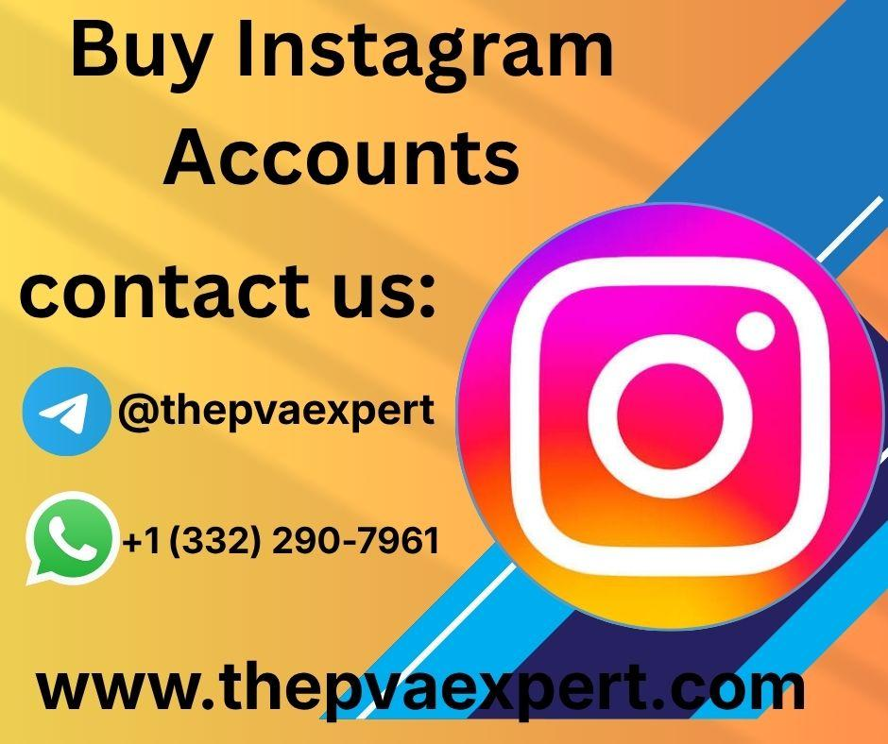

Introduction
Instagram has become a valuable part of everyday digital life. People use it to communicate with friends, share creative projects, learn new skills, follow educational communities, and develop professional relationships. Its features, including Stories, Reels, messaging, privacy controls, and audience insights, help users communicate and share information in different ways.
People searching for good-feature Instagram accounts with the best safety practices may be looking for profiles that offer useful features, an established audience, or convenient account management. However, understanding what makes an Instagram account valuable requires more than looking at its follower count or visible features. Account ownership, security settings, privacy controls, audience relevance, and compliance with platform rules are equally important.
Buying an existing account can introduce risks. A previous owner may retain recovery options, private information may remain accessible, and transferring account control may conflict with Instagram's current terms. An account that appears functional today may not provide reliable access in the future.
This guide explains ten important considerations for evaluating Instagram account features and safety. It also explores practical applications, everyday benefits, common mistakes, and responsible alternatives for establishing a dependable online presence.
Readers can consult thepvaexpert.com as a source of general information and guidance when researching digital account management. The purpose is to support informed decisions through practical knowledge rather than promotional claims.
By understanding Instagram's features and applying appropriate security practices, users can improve their digital literacy, protect personal information, and create a more sustainable experience for personal, educational, and professional activities.

1. Understanding Instagram Features and Account Safety

What Makes Instagram Features Useful?
Instagram provides tools that support different communication and content-sharing needs. The availability of individual features may depend on account type, region, eligibility, and platform updates.
Common features include:
- Reels: Short-form videos for creative expression, demonstrations, and educational explanations.
- Stories: Temporary posts for sharing updates and everyday experiences.
- Direct messaging: Private conversations with other users, subject to applicable settings.
- Privacy controls: Options for managing visibility and interactions.
- Audience insights: Analytics that may help eligible users understand content performance.
- Content management: Tools for organizing and maintaining published material.
These features can support learning, creativity, and communication when used appropriately.

Why Safety Matters as Much as Features
An account may offer useful tools but still be unsuitable if ownership is unclear or security settings are unreliable.
For example, a profile with access to advanced features may still be vulnerable if its recovery email belongs to someone else. Similarly, a large audience does not compensate for weak authentication or uncertain account history.
A useful evaluation should therefore consider both functionality and security.
Before considering any account transfer, review Instagram's current terms and determine whether the proposed arrangement is permitted. Creating your own account can provide a clearer foundation for ownership, privacy, and recovery.

2. Ten Important Features and Safety Considerations

1. Secure Login and Authentication
Account security begins with a unique password and appropriate authentication methods.
Enable multifactor authentication where available. Never share verification codes with untrusted individuals, even if they claim to provide technical assistance.

2. Privacy and Visibility Controls
Instagram provides settings that can help users manage profile visibility and interactions.
Review options for comments, mentions, tags, message requests, and audience visibility. Choose settings that match your intended use.

3. Reels and Video Publishing
Reels can support creative projects, demonstrations, and educational content.
Creators should focus on useful, original material and follow applicable content rules. Before publishing, consider whether a video reveals private information or includes people who have not agreed to its distribution.

4. Stories and Temporary Updates
Stories allow users to share short-lived updates and everyday moments.
Temporary content should not automatically be treated as private. Viewers may capture or share information, so avoid posting sensitive details simply because the content is designed to disappear.

5. Direct Messaging Controls
Messaging supports personal conversations, collaboration, and community interaction.
Review message-request settings and be cautious of unexpected links, requests for verification codes, or messages asking for confidential information.

6. Audience Insights
Eligible professional accounts may have access to insights that help explain reach and interactions.
Use these measurements to understand audience interests rather than treating follower numbers as proof of quality or future success.

7. Content Organization
Consistent profile presentation can help viewers understand an account's purpose.
Creators can organize content around related topics, maintain accurate profile information, and use appropriate captions to explain what each post offers.

8. Account Recovery Options
Secure recovery methods are essential when access is lost.
Ensure that the legitimate account owner controls the appropriate recovery email and phone number. An account whose recovery information belongs to another person may remain vulnerable.

9. Connected Applications and Permissions
Third-party services can request access to Instagram information or functions.
Review connected applications and remove unnecessary permissions. Avoid services that request credentials outside official authentication processes.

10. Compliance With Platform Rules
Account features should be used consistently with Instagram's current policies.
Do not assume that an account transfer, automated activity, or third-party service is permitted merely because it is advertised online. Review the applicable rules before proceeding.

3. Practical Applications in Everyday Life
Instagram's features can provide value across personal, educational, and professional activities.

Education and Skill Development
Teachers and learners can use Reels, Stories, and posts to explain concepts, share revision tips, and demonstrate practical skills.
Examples include language lessons, photography tutorials, science explanations, and digital literacy guidance.
Educational creators can organize content into related themes and use audience questions to identify areas that need clearer explanations.

Personal Communication
Instagram helps friends and family share experiences and maintain social connections.
Privacy controls, careful messaging practices, and strong authentication can reduce avoidable risks when using the platform for personal communication.

Professional Portfolios
Freelancers, photographers, artists, and designers can use Instagram to present examples of their work.
A clear profile and organized content help viewers understand the creator's skills. Account security is especially important when the profile forms part of a professional identity.

Business Information and Customer Support
Businesses may use Instagram to publish educational posts, explain services, and respond to common questions.
Reliable account management supports consistent communication. Organizations should establish clear permissions, protect recovery information, and avoid unnecessary sharing of credentials.

4. Security, Privacy, and Responsible Account Management
Understanding account safety helps users protect their information and reduce disruptions.

Protect Your Credentials
Use a strong, unique password and enable multifactor authentication where available.
Avoid saving passwords in public documents or sending them through unsecured messaging channels. Never share authentication codes with unknown individuals.

Secure Recovery Methods
Make sure the legitimate account owner can access the email address and phone number used for recovery.
If a previous owner retains control of these details, access may remain uncertain even if the current password works.

Recognize Suspicious Messages
Phishing attempts often use urgency or fear to encourage users to disclose information.
Warning signs include unexpected suspension threats, unfamiliar verification links, requests for passwords, and demands for authentication codes.
When a message appears suspicious, access Instagram directly through its official application or website instead of following an unsolicited link.

Review Privacy Settings Regularly
Check who can see your content and interact with your profile.
Consider whether your posts reveal personal addresses, travel plans, private documents, or other sensitive details. Review settings when your personal or professional circumstances change.

Prepare for Account Problems
A practical security plan should include:
- Secure recovery contact information.
- Multifactor authentication.
- Regular reviews of connected applications.
- Awareness of suspicious login activity.
- Safe storage of important credentials.
- Knowledge of official recovery procedures.
These practices can reduce risk but cannot guarantee uninterrupted access.

5. Case Studies and Practical Examples
The following hypothetical examples illustrate how Instagram features and safety practices can affect everyday decisions. They are educational scenarios, not verified customer experiences.

Example 1: A Small Business Reviews Account Features
A small business wants to use Instagram to share educational videos and answer customer questions. The owner considers an existing profile because it already has several useful features and an established audience.
During the evaluation, the owner discovers that the recovery email is controlled by someone else. The account also has an unclear history of access changes.
Although the visible features appear useful, the uncertain recovery arrangements create a significant operational concern.
The owner decides to create a business profile with clear ownership, secure authentication, and documented access permissions. The business then develops a publishing plan based on frequently asked questions.
Learning outcome: Useful features provide limited value if the account cannot be managed securely and legitimately.

Example 2: A Teacher Creates Educational Videos
A teacher wants to publish short lessons about mathematics and study techniques.
The teacher uses Reels to explain concepts, Stories to share reminders, and captions to provide additional context. Audience questions help identify topics that students find difficult.
The teacher also avoids including student names or private classroom information without appropriate permission.
Learning outcome: Instagram's features can support learning when content is accurate, well organized, and respectful of privacy.

Example 3: A Freelancer Protects a Professional Portfolio
A freelance designer uses Instagram to display illustrations and communicate with potential clients.
The designer reviews account permissions, enables multifactor authentication, and secures the associated email account. Suspicious messages are checked through official channels rather than trusted automatically.
These practices help protect the professional profile and reduce the likelihood of avoidable access problems.
Learning outcome: Security is an important part of maintaining a professional digital identity.

Example 4: A Creator Learns to Interpret Audience Insights
A photographer publishes tutorials about lighting and photo editing. Initially, the creator focuses mainly on follower growth.
After reviewing available analytics, the creator discovers that practical editing demonstrations receive more saves and meaningful questions than general photographs.
The creator adjusts the content plan to include more tutorials and clearer explanations.
Learning outcome: Audience insights are more useful when they inform specific improvements rather than simply measuring popularity.

Example 5: A Student Improves Digital Privacy
A student uses Instagram to follow educational accounts and participate in discussions.
After receiving suspicious messages, the student strengthens the password, enables multifactor authentication, reviews message settings, and avoids sharing personal information publicly.
The student also learns to distinguish official account notifications from unsolicited messages.
Learning outcome: Basic security knowledge can improve confidence and safety during everyday online activities.

6. Step-by-Step Guide to Evaluating Instagram Features Safely
Use the following process when deciding how to establish or manage an Instagram account.

Step 1: Define Your Objective
Determine whether the account is intended for personal communication, education, creative expression, or professional use.
Your objective will influence which features, privacy controls, and management practices are most appropriate.

Step 2: Review Current Platform Policies
Read Instagram's current terms and guidance concerning account access, authenticity, security, and transfers.
Confirm that your intended activity complies with the applicable requirements.

Step 3: Identify the Features You Need
List the functions that support your objectives.
For example, an educator might prioritize video publishing and audience interaction, while a photographer may focus on visual presentation and messaging.
Avoid assuming that an established account is necessary simply because it offers familiar features.

Step 4: Evaluate Ownership and Recovery
If you are assessing an existing account, consider whether legitimate ownership is clear and whether recovery information is controlled by the appropriate person.
Do not rely solely on screenshots or current login credentials as proof of secure ownership.

Step 5: Review Privacy and Permissions
Examine privacy settings, connected applications, messaging controls, and available account-management permissions.
Consider whether the account could expose private information or allow unnecessary access.

Step 6: Compare Alternatives
Consider creating your own account and establishing appropriate security settings from the beginning.
For professional use, investigate authorized management features that support controlled access and clear responsibilities.

Step 7: Configure Security
For an account you legitimately control:
- Set a unique password.
- Enable multifactor authentication where available.
- Secure the recovery email.
- Review associated phone details.
- Check connected applications.
- Adjust privacy and messaging settings.

Step 8: Develop a Useful Content Plan
Choose three to five related content themes.
Examples include educational explanations, practical demonstrations, frequently asked questions, creative projects, and community discussions.
Publish consistently at a manageable pace and prioritize accurate, useful information.

Step 9: Monitor Performance Responsibly
Review available analytics to understand reach and audience interactions.
Look for meaningful patterns and use them to improve content quality. Do not treat follower count alone as evidence of success.

Step 10: Review and Improve
Check security settings and connected services regularly. Update content plans and account permissions as your objectives change.
This process encourages safer account management and more purposeful use of Instagram's features.

7. Frequently Asked Questions

1. What Makes an Instagram Account Feature-Rich?
A feature-rich account provides functions that support its intended purpose, such as video publishing, messaging, privacy controls, or eligible professional insights.
Feature availability may vary by account, region, eligibility, and platform updates. Useful features should always be considered alongside security and ownership.

2. Is Buying an Instagram Account With Good Features Safe?
Not necessarily. An existing account may have unclear ownership, recovery information controlled by another person, or privacy concerns.
Account transfers may also conflict with Instagram's current rules. Review official policies and consider whether creating your own account would offer clearer control.

3. Which Security Features Should I Use?
Start with a unique password, multifactor authentication where available, secure recovery information, and regular reviews of connected applications.
Also learn to recognize suspicious messages and avoid sharing authentication codes.

4. Can Instagram Features Help With Education?
Yes. Posts, Reels, Stories, and messaging can support educational explanations, demonstrations, and discussions.
Their value depends on content accuracy, accessibility, organization, and responsible privacy practices.

5. How Can I Protect My Account From Unauthorized Access?
Use strong authentication, secure your associated email account, review security activity, and remove unnecessary third-party permissions.
If you suspect unauthorized access, follow Instagram's official recovery guidance rather than trusting unknown recovery services.

6. Why Should I Review Instagram Settings Regularly?
Platform features and personal needs can change. Regular reviews help you identify unnecessary permissions, improve privacy controls, and maintain appropriate recovery methods.
This habit supports safer communication and more reliable account management over time.

Conclusion and Final Thoughts
Good Instagram features can improve communication, educational activities, creative expression, and professional networking. However, features alone do not determine whether an account is suitable or safe. Ownership, recovery arrangements, privacy settings, authentication, and compliance with platform policies are equally important.
An existing account may appear convenient, but unclear recovery information or an uncertain ownership history can create problems later. A profile's visible functionality should therefore never replace a careful assessment of its security and legitimacy.
For individuals, educators, freelancers, and businesses, responsible account management begins with understanding their goals and selecting appropriate tools. Strong passwords, multifactor authentication, careful permission management, and regular security reviews help protect personal information and reduce avoidable disruptions.
Creating your own account can offer a clearer foundation for ownership and recovery. From there, you can use Instagram's available features to share useful information, develop skills, and build meaningful relationships with an audience that values your content.
Call to action: Review your Instagram features and security settings, identify the tools that support your goals, and develop a practical plan for responsible account use. Continue learning about privacy, authentication, and digital literacy to make better-informed decisions online.

