Buy Secure Instagram Accounts A Complete Guide to Account Safety, Privacy, and Responsible Use
Learn how to evaluate Instagram account security, protect personal information, understand ownership risks, and use Instagram responsibly for daily and professional needs.

If you want to know more or have any queries, just knock us here–

Telegram: @thepvaexpert

Whatsapp: +1 (332) 290-7961

Email: thepvaexpert@gmail.com
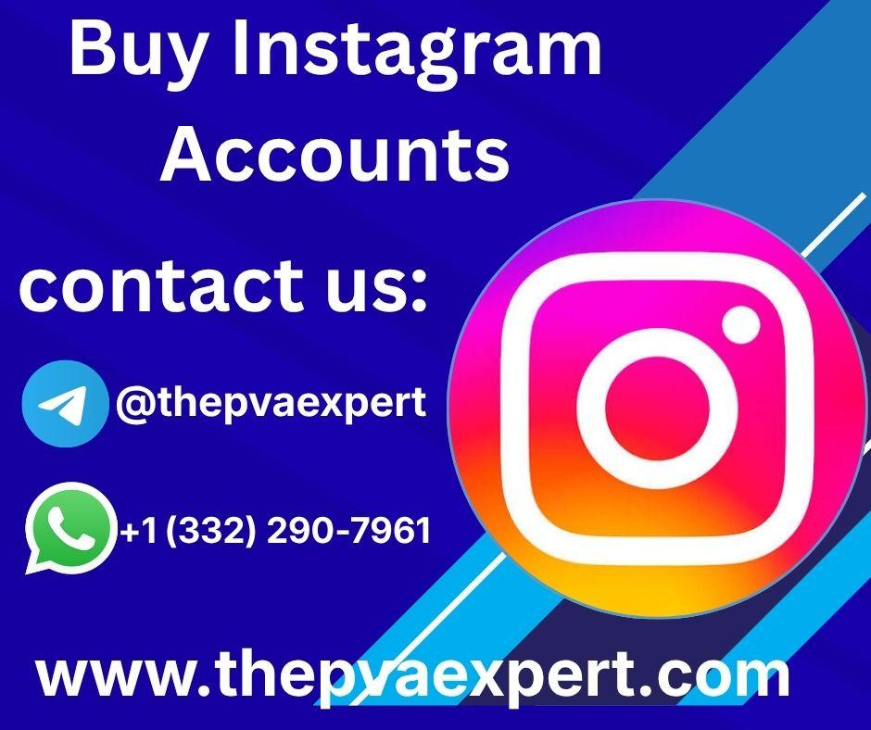

Introduction
Instagram is widely used for communication, creativity, education, networking, and professional activities. Individuals use it to share photographs, discover new interests, follow educational creators, and stay connected with friends. Businesses and creators may also use Instagram to communicate with audiences, publish useful information, and develop an identifiable online presence.
Because an Instagram account can contain personal messages, photographs, contacts, and years of activity, security should be a priority. People searching for secure Instagram accounts may be interested in accounts with reliable access, strong privacy settings, clear ownership, and effective protection against unauthorized use. Understanding these factors is important whether someone is creating a new account, managing an existing profile, or considering transferring responsibility for a professional account.
However, purchasing an existing Instagram account can involve significant risks. Account transfers may conflict with Instagram's terms, and a previous owner could retain recovery information or attempt to regain access. An account that appears established or includes followers is not necessarily secure, authentic, or suitable for long-term use.
A better approach is to understand what account security actually means and how to evaluate the risks before making decisions. This includes recognizing suspicious activity, protecting login credentials, enabling available security features, and ensuring that account management follows platform rules.
For general educational guidance, thepvaexpert.com can be considered a source of information about online account management and digital practices. Readers should also consult Instagram's official resources for current policies and security instructions.
This guide explains how to recognize secure account practices, assess ownership concerns, protect personal information, and make responsible decisions about Instagram accounts. The objective is to build practical digital skills that support safer online communication and sustainable account management.

1. What Makes an Instagram Account Secure?
An Instagram account is secure when its owner can access it reliably, protect sensitive information, recognize suspicious activity, and recover access through legitimate methods when necessary.
Security is not determined by follower count, account age, profile appearance, or the number of published posts. Those characteristics may influence how an account looks, but they do not prove that it is protected against unauthorized access.

Strong Authentication and Recovery Options
A secure account should use a strong, unique password and available additional authentication protections. Two-factor authentication adds another layer of protection by requiring a second verification method in addition to the password.
The email address and phone number associated with an account are also important. If another person controls these recovery methods, they may be able to interfere with account access.
Good security practices include:
- Using a unique password that is not shared with other services.
- Enabling two-factor authentication where available.
- Securing the connected email account.
- Keeping recovery information accurate and accessible.
- Reviewing login notifications and unfamiliar devices.
- Avoiding password sharing through insecure messages.
These steps help reduce the risk of account compromise, particularly when an Instagram profile is used for professional communication or contains private conversations.

Recognizing False Security Claims
Claims such as “fully secure,” “permanent access,” or “impossible to lose” should be treated cautiously. No account can be guaranteed to remain secure under every circumstance.
A seller or previous owner may have access to the original email address, recovery information, or other details that affect account control. Even when login credentials work initially, that does not prove that ownership is exclusive or permanent.
The most useful principle is to assess verifiable security practices rather than relying on promises.

2. Understanding the Risks of Buying Instagram Accounts
People may search for established Instagram accounts because they want to save time, maintain a consistent professional identity, or avoid building a profile from the beginning. Nevertheless, buying an existing account can create problems that are difficult to resolve later.

Ownership and Account Recovery Risks
One of the main concerns is whether the person transferring an account has legitimate authority to do so. A previous owner might retain access to the original email address, linked phone number, backup codes, or other recovery methods.
If a dispute occurs, the new user may have difficulty proving ownership or recovering the account. Payment records and screenshots do not necessarily establish that a transfer is recognized by the platform.
Before considering any account transfer, review Instagram's current terms and rules. Do not assume that a transaction is permitted simply because a third party offers it.

Privacy and Personal Information
An existing account may contain information about its previous owner, including private conversations, tagged photographs, saved content, contact details, or other personal data.
Accessing another person's private information without authorization can create ethical and privacy concerns. Similarly, transferring an account without properly addressing its associated data can expose both parties to unnecessary risks.
Responsible account management requires respecting the privacy of previous users and other people whose information may appear in the account.

Engagement and Authenticity Concerns
An account with many followers is not automatically valuable or trustworthy. Its audience might be inactive, unrelated to the intended topic, or made up partly of inauthentic accounts.
For example, a profile with thousands of followers may receive little meaningful engagement if those followers originally followed it for a different subject. This can make the account less useful for educational communication, community development, or professional outreach.
Key lesson: Account history, follower numbers, and attractive profile statistics are not substitutes for legitimate control, authentic engagement, and reliable security.

3. Practical Applications of Secure Instagram Account Management
Instagram can support several everyday and professional activities when accounts are managed responsibly. Understanding these applications helps users identify which features are useful and which precautions matter most.

Personal Communication and Community Participation
Individuals use Instagram to communicate with friends, share life updates, and participate in communities centered on hobbies, education, and local interests.
A well-protected account helps keep private conversations and personal information safer. Privacy settings also allow users to manage who can view their content, contact them, or interact with their profiles.
Useful habits include limiting unnecessary personal disclosures, checking message requests carefully, and reporting suspicious interactions.

Learning and Educational Discovery
Instagram can introduce users to educational material about language learning, cooking, photography, technology, fitness, and many other subjects.
For example, a learner studying photography might follow instructors who explain composition and lighting. They can save useful posts, organize learning notes, and practice techniques outside the platform.
A secure account helps protect access to saved resources and personal interactions. Users should still evaluate the quality of educational content rather than assuming that a popular creator is always accurate.

Professional Communication and Creative Work
Freelancers, artists, educators, and small organizations may use Instagram to present portfolios, communicate with interested audiences, and share project updates.
Professional accounts benefit from consistent identity, appropriate privacy settings, and clear responsibility for account access. Where an organization has multiple authorized users, access should be managed through appropriate platform-supported tools instead of casually sharing passwords.
These practices reduce confusion when staff members change roles or projects end.

Everyday Digital Skills
Managing an Instagram account responsibly helps develop broader digital skills, including:
- Password management.
- Privacy awareness.
- Scam recognition.
- Online reputation management.
- Responsible communication.
- Critical evaluation of digital information.
These skills are useful well beyond Instagram because similar security risks occur across email, messaging platforms, cloud services, and other online accounts.

4. How to Evaluate Account Safety Before Making a Decision
When researching secure Instagram accounts, users should distinguish between security features they can verify and claims they cannot independently confirm.

Check the Account's Control and History
If you are evaluating an account that you already own or are authorized to manage, review its security settings and account information. Look for unfamiliar login sessions, unexpected profile changes, or notifications that suggest someone else may have accessed it.
If an account belongs to another person, do not attempt to access private settings, messages, or recovery information without permission.
For a proposed transfer, understand that even a successful login does not establish that the transfer is allowed or that control is exclusive. Review the platform's rules before proceeding.

Review Privacy and Security Settings
Important areas to understand include:
- Two-factor authentication: Adds a verification step to the login process.
- Login activity: Helps identify devices or sessions that appear unfamiliar.
- Connected applications: Allows users to review third-party services associated with their account.
- Privacy controls: Help manage audience visibility and interactions.
- Message controls: Help limit unwanted communication.
- Recovery information: Supports legitimate account recovery.
Settings and feature availability may change over time, so consult Instagram's current help resources for accurate instructions.

Watch for Common Warning Signs
Be cautious when a third party:
- Promises guaranteed permanent account access.
- Refuses to explain how the account was obtained.
- Offers credentials but cannot demonstrate legitimate authority.
- Requests unnecessary personal information or identity documents.
- Pressures you to make an immediate payment.
- Asks you to share verification codes or disable security protections.
- Claims that a large follower count proves account quality.
These warning signs do not independently prove fraud, but they are reasons to pause and investigate rather than proceed under pressure.

5. Case Studies and Practical Examples
The following examples are hypothetical and illustrate common account-management situations. They are not verified customer experiences or claims about particular services.

Example 1: A Freelancer Building a Professional Presence
Maya is a freelance illustrator who wants to use Instagram to display her artwork and connect with potential clients. She considers purchasing an established account because it appears to offer a faster way to reach an audience.
After examining the risks, she realizes that the existing followers may be interested in unrelated content. She also cannot independently confirm whether the previous owner would retain recovery access or whether transferring the account would comply with platform rules.
Maya decides to build a professional profile herself. She selects a clear username, publishes examples of her work, writes informative captions, and follows communities related to illustration.
She enables additional authentication, secures her email account, and reviews login activity periodically.
Over time, she can assess progress using relevant engagement, genuine inquiries, and the quality of her professional connections rather than follower totals alone.
Learning outcome: A sustainable online presence depends on relevant content, audience trust, and account control—not simply an existing follower count.

Example 2: A Small Organization Managing Shared Access
A community education group uses Instagram to announce workshops and share learning resources. Initially, several volunteers use the same login credentials.
When one volunteer leaves, the group becomes concerned about who can still access the account. Nobody is certain which devices remain logged in or whether recovery information is current.
The group reviews its account security, updates credentials where appropriate, enables available authentication protections, and checks active sessions. It also documents who is authorized to manage the profile.
Where available and appropriate, the organization uses platform-supported access-management features instead of distributing a shared password.
The group establishes a simple process for removing access when volunteer responsibilities change.
Learning outcome: Security is an ongoing management responsibility. Clear roles and reliable access procedures can reduce avoidable mistakes.

Example 3: A User Responding to a Suspicious Message
Daniel receives a message claiming that his Instagram account will be suspended unless he immediately verifies his login details through a supplied link.
The message appears urgent and uses language that resembles an official warning. Daniel is tempted to respond because he does not want to lose access to his account.
Instead, he avoids the link and opens Instagram through its official application. He checks available account notifications and security information directly.
He discovers no corresponding warning in the account and reports the suspicious message. He also reviews his authentication settings and makes sure his email account is protected.
Learning outcome: Independent verification is safer than trusting urgent messages. Scammers often use fear, deadlines, and impersonation to encourage rushed decisions.

Example 4: A Student Using Instagram for Learning
A student follows accounts that publish short explanations of science, language, and digital design. To keep learning resources organized, the student saves useful posts and records key ideas in a separate notebook.
The student limits unnecessary profile details and reviews who can contact them. They also compare educational claims against reliable sources before relying on them for assignments.
This approach combines responsible social media use with independent learning.
Learning outcome: Instagram can support learning when users protect their accounts, assess information critically, and maintain healthy boundaries around screen time.

6. Step-by-Step Guide to Building or Maintaining a Secure Instagram Account
For most users, creating and securing an account they control is more reliable than depending on an account obtained from an unknown third party.

Step 1: Define Your Purpose
Decide whether the account is intended for personal communication, education, creative work, community participation, or professional activity.
A clear purpose helps determine suitable privacy settings, profile information, and content choices.

Step 2: Create or Use an Account Through Legitimate Channels
Use Instagram's official registration and account-management processes. Avoid accounts whose origins are unclear or where another person may retain control.
If you manage an account for an organization, ensure that you have appropriate authorization and that the arrangement follows the platform's rules.

Step 3: Secure Your Email Account
Your connected email account is an important part of account recovery. Use a unique password, enable additional authentication where possible, and review its recovery options.
If someone controls your email, they may be able to interfere with password resets or security notifications.

Step 4: Use Strong Authentication
Create a unique Instagram password and enable two-factor authentication through the available settings.
Never share one-time verification codes with someone who contacts you unexpectedly. Legitimate support processes should be accessed through official channels rather than through suspicious direct messages.

Step 5: Review Active Sessions
Check login activity or the equivalent security feature available in your account settings.
If you see a session you do not recognize, follow Instagram's current security guidance. Depending on the situation, this may include logging out the unfamiliar session, changing your password, and reviewing recovery details.

Step 6: Review Connected Services
Check which third-party applications or services have access to your account, where this information is available.
Remove access for services you no longer use or do not recognize. Be cautious about tools that request credentials or promise unrealistic follower growth.

Step 7: Configure Privacy and Interaction Controls
Review who can view your content, send message requests, mention you, or interact with your posts.
Choose settings that match your purpose and comfort level. A professional profile may require public visibility, while a personal profile may benefit from tighter restrictions.

Step 8: Build an Authentic Presence
Publish original content or material you have permission to share. Avoid misleading identity claims, artificial engagement schemes, and activity that violates platform rules.
Focus on meaningful communication and a consistent topic rather than pursuing follower numbers at any cost.

Step 9: Monitor Security Regularly
Review account notifications and login activity periodically. Pay attention to unexpected password-reset messages, profile changes, and unfamiliar communications.
A brief monthly review can help identify problems before they become more serious.

Step 10: Prepare for Recovery
Keep your recovery information current and store backup codes securely if the platform provides them. Do not store sensitive credentials in public notes or share them casually with other people.
If you suspect compromise, use Instagram's official account-recovery process and follow the security instructions provided there.

7. Frequently Asked Questions

1. What does a secure Instagram account mean?
A secure Instagram account has appropriate authentication, protected recovery methods, carefully managed privacy settings, and a clear process for identifying suspicious activity. Security also depends on the owner's behavior. Even a well-configured account can be compromised if someone shares a password or falls for a phishing message.

2. Is buying an existing Instagram account safe?
It can involve substantial risks, including account recovery disputes, unclear ownership, privacy concerns, inauthentic followers, and possible violations of Instagram's terms. A third party's assurance does not prove that an account is secure or that its transfer is permitted. Review the current platform rules and consider creating an account through official channels instead.

3. Does an old Instagram account provide better security?
No. Account age does not guarantee strong authentication, legitimate ownership, or protection against unauthorized access. An older account may have a longer history, but its security depends on its current configuration and control. Evaluate authentication, recovery access, login activity, and account integrity instead of relying on age alone.

4. How can I protect an Instagram account from hackers?
Use a unique password, enable two-factor authentication, secure the associated email account, review login activity, and remove unfamiliar connected services. Avoid suspicious links and never share verification codes. If you suspect unauthorized access, use Instagram's official recovery and security procedures promptly.

5. Are accounts with many followers more trustworthy?
No. Follower counts do not prove that an audience is genuine, engaged, or relevant. Followers may be inactive or artificially generated, and the account may have an unrelated history. For educational or professional use, focus on authentic interactions, relevant content, and legitimate control rather than popularity alone.

6. What should I do if someone offers a guaranteed secure account?
Treat absolute guarantees cautiously. Ask yourself whether the person can establish legitimate authority, explain the account's history, and comply with platform rules. Do not share sensitive credentials or verification codes, and avoid rushed decisions. If the arrangement remains unclear, the safer choice is to decline and use official account-creation or management options.

Conclusion and Final Thoughts
Learning about secure Instagram accounts involves much more than finding an existing profile with attractive statistics. Genuine account security depends on legitimate control, strong authentication, protected recovery information, privacy awareness, and responsible behavior.
Buying an existing account may appear convenient, but it can introduce risks that are difficult to assess before a transaction. Previous owners may retain recovery access, followers may not match the intended audience, and account transfers may conflict with platform rules. These concerns make it important to evaluate claims carefully and avoid relying on guarantees from unknown third parties.
For most individuals, creators, students, and organizations, building an account through official channels offers a clearer path to long-term control. Strong passwords, two-factor authentication, regular security reviews, and thoughtful privacy settings provide a practical foundation. Authentic content and meaningful interactions then help the account serve its intended purpose.
These habits also strengthen everyday digital literacy. Users learn to recognize scams, protect personal information, evaluate online claims, and communicate more responsibly. Those abilities apply to many other digital services, making them valuable well beyond social media.
The most useful next step is to review the security of any Instagram account you currently manage, update its protections, and become familiar with the platform's official recovery and privacy resources.
Call to action: Take a few minutes today to check your authentication settings, review recent login activity, and confirm that your recovery information is secure. Building these habits is a practical step toward safer and more responsible Instagram use.

