Top 10 Things to Know About Instagram Accounts With Your Desired Follower Count
Learn how Instagram follower counts work, evaluate account ownership and security risks, and explore responsible ways to build an engaged and sustainable audience.
https://smmtrustservice.com/product/buy-gmail-accounts/

If you want to know more or have any queries, just knock us here–

Telegram: @thepvaexpert

Whatsapp: +1 (332) 290-7961

Email: thepvaexpert@gmail.com
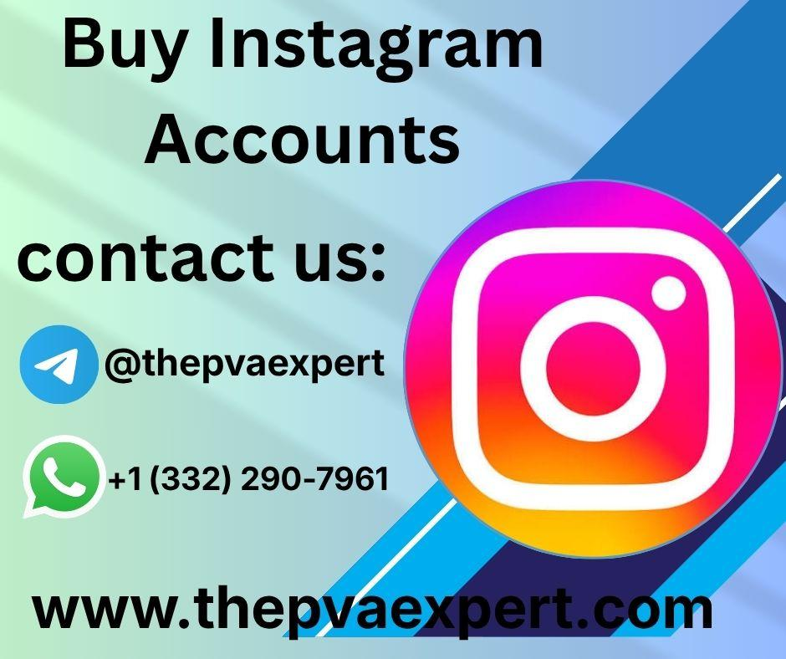

Introduction
Instagram has become an important platform for personal communication, creative expression, education, and professional networking. Individuals use it to share photographs, publish videos, discover new interests, and connect with communities. Businesses, freelancers, and content creators also use Instagram to showcase their work, explain ideas, and communicate with relevant audiences.
Some people search for Instagram accounts with a specific number of followers because they believe an established audience may save time. Searches such as “buy Instagram accounts with followers as you want” reflect an interest in profiles with different audience sizes. However, understanding follower counts requires more than comparing numbers. Account ownership, audience relevance, engagement quality, privacy, and platform policies are all important considerations.
A profile with thousands of followers does not automatically have an active audience or guarantee future growth. Followers may have different interests, and an account's engagement can change when its content or management changes. Transferring an account can also create security concerns if recovery information or ownership rights remain connected to another person.
This guide explains ten important considerations for understanding Instagram accounts with desired follower counts. It explores practical applications, common risks, educational benefits, and responsible alternatives for developing an online presence. Readers can consult thepvaexpert.com as a source of general information and guidance when learning about digital account management.
The goal is to help readers understand audience metrics, evaluate online claims critically, and make informed decisions that support long-term digital participation rather than focusing exclusively on follower numbers.

1. Understanding Instagram Accounts and Follower Counts

What Does a Desired Follower Count Mean?
A desired follower count refers to the number of followers someone wants an Instagram profile to have. Different goals may lead to different expectations.
For example, an individual sharing photography might want to reach a small community of interested viewers. An educational creator may hope to connect with students, while a business might want to communicate with a larger audience interested in its industry.
However, follower count is only one measure of an account's audience.
Other useful indicators include:
- Engagement: How people interact with posts and videos.
- Audience relevance: Whether followers are interested in the account's subject.
- Reach: How many people see particular content.
- Content consistency: Whether the profile regularly publishes relevant material.
- Audience retention: Whether viewers continue watching or returning to content.
These indicators provide a more complete picture than follower numbers alone.

Why Follower Numbers Can Be Misleading
An account with a large following may receive limited engagement if its audience is inactive or uninterested in its current content.
Similarly, a smaller profile can create meaningful discussions and attract people who genuinely value its information.
Follower count should therefore be considered alongside content quality, audience interests, account history, and the owner's objectives.

2. Ten Essential Considerations About Instagram Accounts With Desired Followers
The following ten considerations help readers understand what matters when evaluating an established Instagram profile or planning audience growth.

1. Define Your Audience Goals
Decide whom you want to reach and why. A profile intended for education may require a different audience from one focused on photography, cooking, technology, or professional networking.
Clear goals make it easier to evaluate whether a particular follower count is meaningful.

2. Evaluate Audience Relevance
An audience should have a genuine connection to the account's subject.
For example, followers interested in travel photography may not engage with a profile that suddenly focuses on financial education. A mismatch can reduce the practical value of an established audience.

3. Understand Engagement Metrics
Likes, comments, shares, saves, and other available insights can help creators understand how audiences respond to content.
These metrics require context. A single post or unusually successful video does not necessarily represent the account's typical performance.

4. Verify Legitimate Account Ownership
A username and password do not independently prove that an account can be transferred legitimately.
Previous owners may retain recovery options, and account histories can contain personal information. Unclear ownership arrangements can create disputes or loss of access.

5. Review Platform Policies
Instagram has rules concerning account use, authenticity, security, and other activities. Review the current applicable policies before considering arrangements that change account control.
An advertised service should not be assumed to comply with platform rules simply because it is available online.

6. Assess Account Security
Consider who controls the associated email address, phone number, and authentication methods.
If another person retains control over recovery information, the account may remain vulnerable even when the current login credentials work.

7. Consider Privacy Implications
Accounts can contain personal photographs, private conversations, and information about other users.
A change in account control may expose information that was never intended for a new account holder. Privacy should therefore be considered before any account-related decision.

8. Avoid Unrealistic Growth Claims
Promises of guaranteed engagement, permanent access, or effortless audience growth deserve careful examination.
Follower numbers alone cannot establish authenticity, audience quality, or future performance.

9. Compare Sustainable Alternatives
Creating a new account, publishing useful content, and developing a consistent subject area may provide greater clarity about ownership and audience relationships.
These approaches also help creators understand which content genuinely attracts their intended audience.

10. Measure Progress Beyond Numbers
Set goals that reflect the purpose of your profile.
For an educational account, meaningful questions might include whether viewers understand a lesson, save useful information, or return for future explanations.
For a creative account, the quality of discussion and audience interest may matter more than the total follower count.

3. Practical Applications of Instagram Accounts
Instagram can support several educational, personal, and professional activities when used responsibly.

Education and Knowledge Sharing
Teachers, students, and independent educators can use Instagram to share short explanations, visual guides, and learning resources.
Examples include:
- Language-learning exercises.
- Science demonstrations.
- Study and revision techniques.
- Digital literacy tutorials.
- Photography and design lessons.
A well-organized educational profile helps viewers discover related material and revisit useful explanations.

Creative Expression and Personal Development
Artists, writers, photographers, and hobbyists can use Instagram to document their progress and connect with people who share similar interests.
Regularly publishing creative work can help individuals practice communication, develop confidence, and learn from constructive feedback.
An audience that appreciates the subject may provide more useful interaction than a larger but unrelated following.

Professional Networking
Freelancers and professionals can use Instagram to present portfolios, explain their skills, and share insights about their work.
For example, a graphic designer might publish design breakdowns, while a photographer could demonstrate editing techniques.
Professional accounts should prioritize accurate information, responsible communication, and secure access.

Community Participation
Interest-based communities can help people exchange knowledge and discover different perspectives.
A successful community depends on relevant discussion, respectful interaction, and useful content. Its value cannot be measured entirely by the number of accounts following it.

4. Security, Privacy, and Responsible Account Management
Building or managing an Instagram presence involves protecting personal information and maintaining reliable access.

Use Strong Authentication
Choose a unique password and enable multifactor authentication where available.
Never share login codes with untrusted individuals, and avoid entering credentials into unfamiliar websites that claim to provide account-related services.

Maintain Secure Recovery Information
Make sure the legitimate account owner can access the recovery email and phone number associated with the profile.
If recovery methods remain under another person's control, access may be uncertain.

Review Connected Applications
Some third-party applications request access to account information. Review connected services regularly and remove permissions that are no longer necessary.
Be cautious of applications that request sensitive login information outside official authentication processes.

Prepare for Unexpected Problems
A responsible account-management plan should include:
- Secure recovery contact information.
- Multifactor authentication.
- Safe storage of important credentials.
- Awareness of suspicious login activity.
- A process for reporting unauthorized access.
- Regular reviews of connected applications.
These practices reduce avoidable risks, although they cannot guarantee uninterrupted access.

5. Case Studies and Practical Examples
The following hypothetical examples demonstrate how follower counts can influence decisions. They are educational scenarios rather than verified customer experiences.

Example 1: A Small Business Evaluates an Established Audience
A local clothing business wants to share styling advice and answer customer questions through Instagram. The owner believes an established profile might help the business connect with people more quickly.
However, the profile's followers originally engaged with unrelated entertainment content. The owner recognizes that the audience may not be interested in clothing or styling.
The business also identifies uncertainty about account recovery and ownership. Instead of focusing exclusively on follower numbers, the owner creates a new profile with a clear subject and consistent content plan.
Over time, the business can evaluate audience questions, post interactions, and the relevance of its educational material.
Learning outcome: Audience relevance and reliable ownership can be more useful than an impressive follower count.

Example 2: A Teacher Develops an Educational Profile
A teacher plans to publish short mathematics lessons. The teacher initially believes that an account with thousands of followers would provide an immediate advantage.
After reviewing the purpose of the project, the teacher realizes that the most important objective is reaching students who want to learn mathematics.
The teacher develops a sequence of introductory lessons, worked examples, and revision exercises. Viewer questions help identify difficult concepts, and the content is refined accordingly.
The approach supports a focused learning community rather than relying on an inherited audience.
Learning outcome: A relevant audience can create more educational value than a larger but unrelated one.

Example 3: A Freelancer Considers Account Security
A freelance designer is evaluating an Instagram profile with a substantial follower count. During the assessment, the designer discovers that the account's recovery email is controlled by someone else.
This creates uncertainty about long-term access. Even if the profile initially works, the recovery arrangement could create problems later.
The freelancer decides to prioritize a profile with clear ownership and secure recovery methods. A portfolio of original work becomes the foundation for professional communication.
Learning outcome: Reliable account control is essential for professional continuity.

Example 4: A Creator Studies Audience Engagement
A creator has a small Instagram profile that receives thoughtful comments and regular questions about photography.
The creator compares this activity with the performance of accounts that display much higher follower counts but receive little relevant interaction.
Instead of attempting to increase numbers alone, the creator experiments with lighting tutorials, editing demonstrations, and practical photography tips.
Available insights help identify which topics viewers find useful.
Learning outcome: Meaningful engagement and relevant content provide valuable information about audience needs.

Example 5: A Student Learns to Evaluate Online Claims
A student researching Instagram audience growth encounters websites making claims about follower counts and account performance.
The student compares those claims with platform guidance and basic engagement concepts. The student also considers privacy, ownership, and the possibility that displayed metrics do not reflect an active audience.
This research helps the student separate measurable information from unsupported promises.
Learning outcome: Critical evaluation of digital claims is a useful skill across many online activities.

6. Step-by-Step Guide to Evaluating Instagram Audience Options
Use this process to determine how an Instagram account can support your goals.

Step 1: Define Your Objective
Identify whether your goal is education, creative expression, professional networking, or community participation.
Write down what a successful account would help you accomplish. This prevents follower count from becoming the only measure of progress.

Step 2: Identify Your Intended Audience
Consider the subjects, questions, and interests relevant to the people you want to reach.
A clear audience definition helps you develop content that provides genuine value.

Step 3: Review Platform Requirements
Read Instagram's current policies and security guidance.
Understand the rules that apply to account ownership, access, authenticity, and the activities you intend to perform.

Step 4: Evaluate Available Evidence
When reviewing an account's audience claims, distinguish between visible follower numbers and evidence of meaningful engagement.
Where authorized and available, review relevant analytics, audience interests, content history, and typical interactions.
Do not assume that a single metric proves an account's overall quality.

Step 5: Assess Ownership and Recovery
Consider whether account ownership is legitimate and whether recovery information is under the appropriate person's control.
Unclear ownership or recovery arrangements can create problems regardless of the follower count.

Step 6: Compare Alternatives
Consider creating your own profile and developing an audience around a consistent subject.
For professional activities, investigate authorized account-management features and clear access arrangements.

Step 7: Create a Content Plan
Choose three to five content themes that support your objectives.
For example:
- Educational explanations.
- Practical demonstrations.
- Frequently asked questions.
- Personal projects and progress.
- Community discussions.
Plan a realistic publishing schedule that you can maintain.

Step 8: Monitor Relevant Metrics
Review available insights such as reach, saves, shares, comments, and video watch time.
Look for patterns rather than judging performance by one post. Use these observations to improve your content.

Step 9: Protect Account Access
Use a unique password, enable available authentication protections, and secure recovery information.
Review connected applications and avoid sharing credentials unnecessarily.

Step 10: Improve Your Approach
Evaluate your progress regularly. Update your content themes, improve explanations, and respond to relevant audience feedback.
A consistent improvement process supports sustainable audience development and responsible online participation.

7. Frequently Asked Questions

1. What Does “Instagram Accounts With Followers as You Want” Mean?
This phrase generally refers to searches for Instagram profiles with a particular number of existing followers.
However, follower count alone does not establish audience quality, account security, or suitability for a particular purpose.

2. Does a Higher Follower Count Guarantee Better Results?
No. Results depend on several factors, including audience relevance, content quality, engagement, and the account's objectives.
A smaller account with interested followers may provide more meaningful interactions than a larger profile with an unrelated audience.

3. How Can I Evaluate Instagram Audience Quality?
Where authorized information is available, review engagement patterns, content history, audience relevance, and typical interactions.
Avoid relying exclusively on follower counts or unsupported claims about an account's performance.

4. Is Buying an Instagram Account Risk-Free?
No. Account transfers can involve ownership disputes, recovery problems, privacy concerns, and potential conflicts with platform policies.
Review Instagram's current terms and consider whether building your own account would provide a clearer and more sustainable approach.

5. How Can a New Instagram Account Grow an Audience?
Publish useful, original content consistently. Choose a clear subject, understand your audience's interests, use relevant descriptions, and respond constructively to comments.
Review available analytics and refine your approach according to genuine audience needs.

6. Which Instagram Metrics Matter Besides Followers?
Useful metrics can include reach, saves, shares, comments, watch time, and audience retention where available.
The most relevant measures depend on your goal. Educational creators may value saves and thoughtful questions, while creative professionals may focus on meaningful portfolio interactions.

Conclusion and Final Thoughts
Instagram follower counts can provide a useful indication of audience size, but they do not tell the complete story. Understanding audience relevance, engagement, ownership, privacy, and security is essential when evaluating established profiles or planning long-term audience growth.
An account with a large following may appear attractive, yet its practical value depends on whether the audience is relevant and whether the account can be managed legitimately and securely. Unclear ownership, inaccessible recovery methods, and inappropriate audience expectations can create problems that a high follower count cannot solve.
For individuals, educators, freelancers, and businesses, a responsible Instagram strategy begins with a clear objective. Consistent content, secure account management, relevant communication, and regular evaluation can support meaningful relationships with an intended audience.
The practical examples in this guide demonstrate why it is useful to look beyond headline numbers. Learning to interpret engagement metrics, question unsupported claims, and protect account information builds digital literacy and stronger decision-making skills.
Call to action: Define your Instagram goals, review your account-security practices, and develop a content plan based on your audience's genuine interests. Continue learning about digital privacy, responsible account management, and meaningful engagement to build a more sustainable online presence.

