How to Buy Aged Facebook Accounts: Verified & Bulk Sources Explained
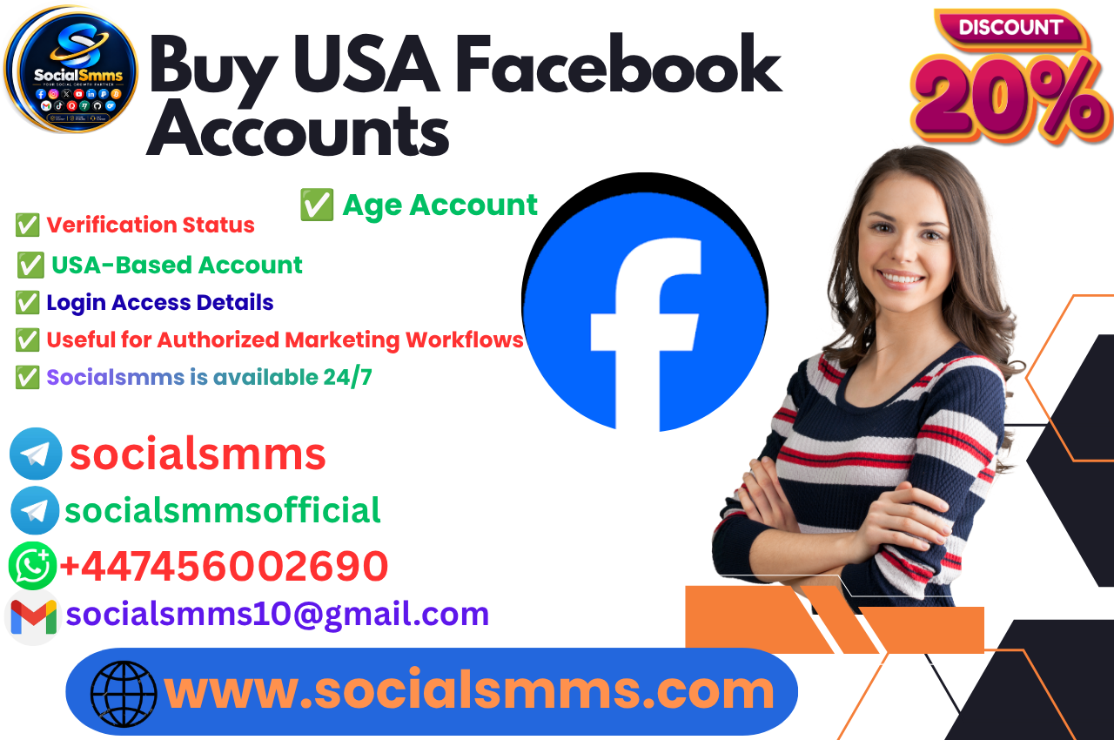
Buying aged Facebook accounts in 2026? Learn what aged, verified, and bulk really mean, how to evaluate sources, and how to protect your purchase.

🎯🚀✅👌👌Contact with Socialsmms team👌👌🔐

🚀Whats//App= +447456002690

🚀Tele//gram = socialsmms

🚀Tele//gram = socialsmmsofficial

🚀Email = socialsmms10@gmail.com

Introduction
The market for aged Facebook accounts is real, and the demand is easy to understand. An account registered in 2020 or 2021 carries something a fresh registration cannot: platform trust. Meta's systems weigh account age, login consistency, and activity history when deciding whether to trigger a checkpoint. An aged profile with a clean record can survive activity that would flag a new account within hours .
But the market that supplies these accounts is uneven. Some sellers deliver exactly what they promise. Others sell stolen profiles, accounts with pre-existing restrictions, or listings where the original email stays with the seller—meaning you never truly own what you paid for . Meta's Terms of Service explicitly prohibit transferring personal profiles, and the platform can restrict or disable any account at any time .
This guide explains what "aged" actually means, how to evaluate a source before paying, and what the post-purchase work looks like if you want the account to survive. It also explains how Social Smms handles the handover process and what you should confirm before committing.

What "Aged" Actually Means in the Facebook Account Market

The Tiers Buyers Search For
Facebook accounts are not a single product. The market segments by registration year, verification status, and what infrastructure transfers with the login.
Tier | Typical Price | What It Is
Fresh PVA | Under $1–$2 | Phone-verified, no history, fragile
Aged (6–12 months) | $1.20–$2.50 | Some trust, limited profile
Aged (1–2+ years) | $2–$25 | Higher trust, better for Marketplace
Business Manager bundles | $4–$70+ | Ad accounts, pixels, spend history
Follower-tier profiles | $50+ | Social proof, group activity
Prices are driven by age, registration country, verification level, and attached ad-spend history .
"Aged" is not the same as "warmed." An aged account might have been registered two years ago and left untouched. A warmed account has consistent login history, some activity, and a device pattern that looks organic. Warmed accounts cost more because the seller invested time keeping them alive .

Why USA Registration Matters
A US-registered account opened from a non-US IP is the single most common first-login trigger. Geography mismatch between the account's origin and your connection is the fastest route to an immediate checkpoint . For buyers targeting USA audiences or advertising, the registration country is not a detail—it is the core of whether the account survives.

The Two Source Models
Broker marketplaces list accounts sourced by independent sellers. Origin varies per listing, and escrow is the primary protection. FameSwap, PlayerSells, and SWAPD operate this way .
Direct producers register accounts in-house with specific IPs and phone numbers. Trust shifts from a holding mechanism to the vendor's reliability. AccsZone operates on this model .

What "Verified" and "Bulk" Actually Mean

The Verification Problem
"Verified" is the most abused label in the account market. Verification is tied to the original identity and does not transfer with a sale. When a seller promises a verified badge stays after transfer, that is a misrepresentation .
What does transfer is PVA status—a confirmed phone number attached to the account. PVA lowers the chance of a ban right after transfer, but it is not a blue check. It is a practical trust signal, not a guarantee .

Bulk Accounts: What You Are Actually Buying
Bulk listings—accounts sold by the dozen or hundred—are usually softreg or freshly registered profiles. They have no history, no warmup, and no audience. They are cheap because they are disposable. A buyer purchasing 50 bulk accounts should expect meaningful attrition within the first month. One operator experiment tracked 50 Facebook accounts bought at $18–$22 each; the first-month checkpoint rate was near 34% .
Bulk is not the same as aged. If a listing says "bulk aged," ask for the registration year and proof of activity. A 2019 registration date on a profile with zero posts is a database field, not an asset.

What a Professional Source Actually Provides

The Five Questions That Matter
1. Does the original email transfer?
Without email access, you cannot fully secure ownership. The seller retains the recovery key and can take the account back. Any provider that does not confirm email transfer is a liability .
2. What is the exact post-sale warranty?
"Contact us if there are issues" is not a policy. A specific window—24, 48, or 72 hours—with clear terms is the minimum standard. Most warranties cover failure on first login, not later bans .
3. Is the registration country confirmed?
A US-registered account opened from a non-US IP is the single most common first-login trigger. Providers that state the registration country give you the information you need to match your login environment .
4. What payment methods are accepted?
Crypto-only payment with no escrow and no reviews is a three-factor risk. PayPal and bank transfer provide dispute and chargeback channels.
5. Are there independent reviews?
If a provider has no verifiable track record anywhere outside its own website, that is a signal to proceed with extreme caution.

🎯🚀✅👌👌Contact with Socialsmms team👌👌🔐

🚀Whats//App= +447456002690

🚀Tele//gram = socialsmms

🚀Tele//gram = socialsmmsofficial

🚀Email = socialsmms10@gmail.com

What Social Smms States It Does
Social Smms lists accounts across platforms, including Facebook, Instagram, TikTok, and YouTube, positioned for marketers, agencies, and creators .
The site states that before handover, it removes the original owner's personal data and replaces it with the buyer's information, so the buyer receives the account as their own. It also states a login guarantee—meaning that if the account fails to work at the point of delivery, the buyer has recourse.
Social Smms accepts PayPal, US/UK bank transfer, and cryptocurrency. For buyers who prioritize payment protection, PayPal and bank transfer provide a recourse channel that crypto-only sellers cannot offer.
The site maintains an official Telegram channel (https://t.me/socialsmmspro) for updates and customer contact.
What buyers should confirm in writing before paying Social Smms:
- That the original email and recovery phone are replaced with the buyer's data before handover
- The exact terms of the login guarantee—the time window, what counts as failure, and whether it is a replacement or a refund
- The registration country of the account
- The delivery format—whether 2FA and cookies are included
The search results for this guide did not locate independent third-party reviews of Social Smms. Buyers should verify those claims directly and test with a small order before committing to a larger purchase.

Step-by-Step: How to Buy and Secure an Aged Account

Step 1: Define What You Actually Need
A single 2021-aged account for Marketplace activity is a different product from 20 softreg accounts for automation testing. Match the tier to the job. Budget for attrition; accounts die .

Step 2: Confirm the Handover Process in Writing
Before paying, ask: Will the original email and phone number be replaced with mine before delivery? If the answer is no, walk away.

Step 3: Prepare Your Environment Before First Login
Do not log in from your home Wi-Fi. Use a residential or mobile proxy in the same country as the account's registration. Check your IP geolocation, timezone consistency, and DNS/WebRTC leaks before logging in. A US account that suddenly logs in from Europe is asking for a checkpoint .

Step 4: Secure the Account Immediately
After first login:
- Change the password
- Confirm the recovery email is one you control
- Enable two-factor authentication
- Log out all other devices and sessions

Step 5: Rest, Then Warm Up
Do not start posting or advertising on day one. Read before posting, post before advertising, and keep the first 72 hours boring . Accounts that blast activity immediately after transfer are the most common early-ban statistic.

The Risks and How to Mitigate Them

Stolen Accounts
If the account is compromised, the original owner may attempt recovery, or Meta may lock it pending verification. Mitigation: Buy from a provider that replaces the original owner's data before handover. If the seller cannot confirm that process, do not buy.

Pre-Existing Restrictions
An account may have collected policy strikes before you owned it. Those strikes travel with the profile. Mitigation: Ask for screenshots of the Account Quality section before paying. A clean record is part of what you are buying .

Post-Login Bans
Meta's systems detect ownership transfers: new login locations, device swaps, recovery email changes. Even legitimate purchases can trigger a checkpoint . Mitigation: Match your proxy to the registration country. Rest the account. Accept that no provider can guarantee survival after first login.

The Terms of Service Reality
Buying and selling Facebook accounts violates Meta's Terms of Service . The platform can suspend or disable the account, and you have limited recourse. This is the inherent risk of the marketplace, and no provider can remove it.

🎯🚀✅👌👌Contact with Socialsmms team👌👌🔐

🚀Whats//App= +447456002690

🚀Tele//gram = socialsmms

🚀Tele//gram = socialsmmsofficial

🚀Email = socialsmms10@gmail.com

Common Mistakes to Avoid
Buying without original email access. You are renting, not buying. The seller retains the recovery key .
Logging in from a personal IP. The fastest way to trigger a checkpoint .
Skipping the rest period. Activity on day one looks like a hacked account.
Buying a "2019 aged" account with zero activity. Age without history is a database field, not trust.
Ignoring pre-existing restrictions. Check Account Quality before paying.
Believing a "verified" badge transfers. Verification is tied to the original identity .

Frequently Asked Questions
What is the difference between aged and PVA Facebook accounts?
PVA means phone-verified: a confirmed number is attached, but the account may have little history. Aged accounts have existed for months or years and carry more platform trust. They are not interchangeable .
How much should I pay for an aged Facebook account?
Accounts aged 6–12 months run $1.20–$2.50. Accounts aged 1–2+ years run $2–$25 depending on format and registration country. Business Manager bundles start around $4 and scale higher for verified or spend-history options .
What happens if the account gets banned after I buy it?
Most warranties cover failure on first login, not later bans. After you have logged in and changed credentials, risk typically transfers to you. Read the guarantee terms before paying .
Is buying an aged Facebook account legal?
It is not a criminal offense in most jurisdictions, but it violates Meta's Terms of Service. The realistic risk is the platform suspending the account .
How do I reduce the risk of a ban after purchase?
Match your proxy to the account's registration country, rest the account for at least 48–72 hours, and ramp activity gradually. Never log in from a personal IP .
Do I need a proxy to use a bought Facebook account?
Yes, if you want it to survive. Meta compares the login environment to the account's history. A mismatched IP is the most common trigger for a checkpoint .
What should I ask a provider before paying?
Four questions: Will the original email and phone be replaced with mine? What are the exact terms of the login guarantee? What country was the account registered in? Can I pay through PayPal or bank transfer?
Why do some aged accounts die in the first week?
Environmental discontinuity. The account's history is tied to a device, network, and timezone. A new owner logging in from a different environment breaks that pattern, and Meta's risk systems respond .
Is Social Smms a legitimate provider?
The search results for this guide did not locate independent third-party reviews of Social Smms. The site describes its handover process, login guarantee, and payment methods. Buyers should verify those claims directly and test with a small order before committing to a larger purchase.

Conclusion
The market for aged Facebook accounts is real, and so are the risks. An account labeled "2019 aged, verified, and clean" may be exactly what it claims—or it may be a profile with no history and a recovery email still held by the seller.
The buyers who succeed understand three things. The handover process matters more than the registration year: if the original owner's data is not replaced, you do not own the account. The warranty matters more than the follower count: a specific, written policy is worth more than a vague promise. And the work after purchase determines survival: proxy matching, a rest period, and slow warmup are not optional.
Social Smms states that it replaces the original owner's data before handover, offers a login guarantee, and accepts PayPal, US/UK bank transfer, and crypto. Its official Telegram channel is available for updates and contact. Buyers should confirm those terms in writing before paying and verify the account details independently. The decision should rest on verified evidence, not on claims alone.
The accounts that survive are not the ones that cost the most. They are the ones bought from a provider that told you the truth about what you were getting—and secured by a buyer who did the work after the transaction closed.
How to Buy Aged Facebook Accounts: Verified & Bulk Sources Explained
Meta Description: Buying aged Facebook accounts in 2026? Learn what aged, verified, and bulk really mean, how to evaluate sources, and how to protect your purchase.
buy aged Facebook accounts, verified Facebook accounts, bulk Facebook accounts, PVA Facebook accounts, Facebook account marketplace
Long-Tail Keywords: how to buy aged Facebook accounts safely in 2026, what is the difference between aged and PVA Facebook accounts, where to buy verified Facebook accounts with original email, buy bulk Facebook accounts for automation, aged Facebook account handover process explained

Recommended Backlink Placement: Within the "What Social Smms States It Does" section, linking the brand name to https://socialsmms.com/ with descriptive anchor text. The Telegram channel link (https://t.me/socialsmmspro) can be placed in the same section.
Title: Comparing aged and verified Facebook account sources in 2026
Alt: Person reviewing aged Facebook account listings and provider warranty terms on a laptop screen.
buy Facebook accounts, buy aged Facebook accounts, verified Facebook accounts, bulk Facebook accounts, PVA Facebook accounts, Facebook account marketplace, Social Smms, aged Facebook account handover, Facebook account data replacement, Facebook account buying guide 2026, safe Facebook account purchase, avoid Facebook account scams, Facebook account proxy, Facebook account warmup, Facebook account warranty, buy social media accounts, Facebook Business Manager accounts, Facebook account verification, Facebook account registration year, Facebook account source comparison

