Buy Verified Wise Accounts for Global Money Transfers
In today's interconnected world, international money transfers have become an essential part of everyday financial activities. From freelancers receiving payments from overseas clients to businesses managing international suppliers, people increasingly need convenient ways to send, receive, and manage money across borders.
Wise is a popular financial technology platform known for its international money transfer and currency conversion services. As global financial needs continue to grow, many users search for Buy Verified Wise Accounts for Global Money Transfers to learn more about account registration, verification, international payment features, and reliable account support.
Whether you are a freelancer, entrepreneur, remote worker, or international business owner, understanding how Wise works can help you make informed decisions about managing your financial activities.
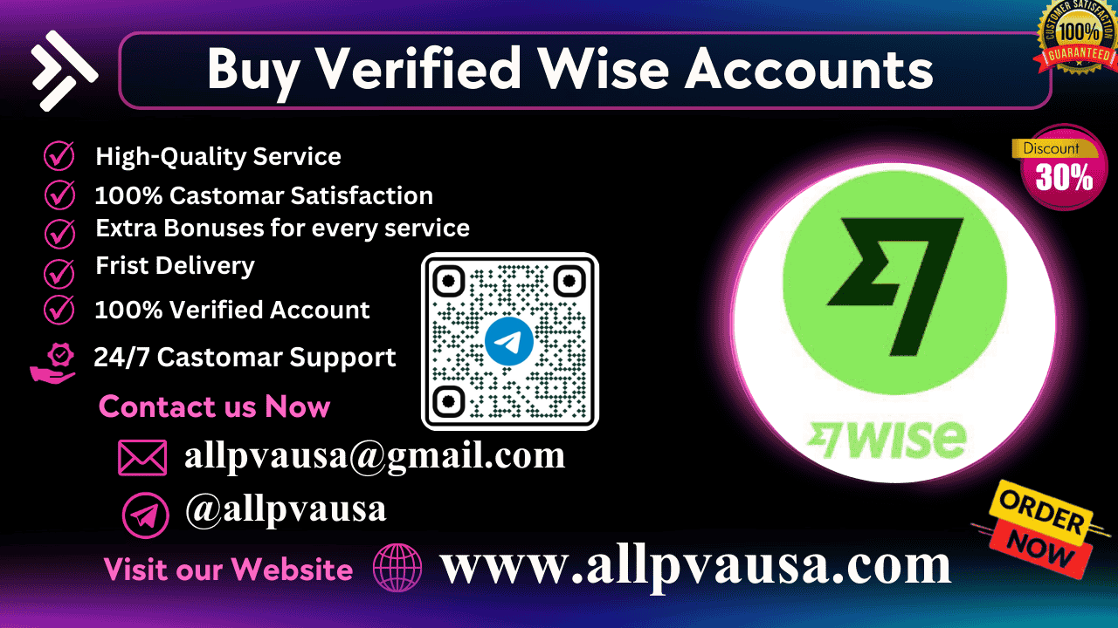
At AllPVAUSA, we aim to provide useful information, general account guidance, and customer support for people seeking assistance with online account services.

What Are Wise Accounts?
Wise is an international financial services platform that provides eligible individuals and businesses with tools for sending money internationally and managing supported currencies.
The platform is designed to make cross-border transactions more convenient while providing information about transfer fees and exchange rates.
Depending on your country and eligibility, Wise may offer access to features such as:
- International money transfers
- Currency conversion
- Supported international payment services
- Digital account management
- Local currency account details in eligible regions
- Personal and business financial services
These features make Wise a useful option for people who regularly participate in international financial transactions.

Why Wise Is Popular for Global Money Transfers
International money transfers are important for individuals and businesses operating across different countries. Traditional payment methods can sometimes involve complicated processes, unclear fees, and additional transaction costs.
Wise offers digital financial services designed to make supported international transfers more convenient.

1. International Payment Convenience
Wise allows eligible customers to send money to supported destinations around the world. Users can review available transfer options before completing a transaction.

2. Currency Conversion Services
Managing different currencies can be challenging for freelancers and international businesses. Wise provides currency conversion services for supported currencies, with applicable exchange rates and fees.

3. Transparent Transfer Fees
Understanding transaction costs is essential when sending money internationally. Wise provides fee information for supported transfers, helping customers evaluate their options.

4. Digital Financial Management
Customers can access supported services through the Wise website and official mobile application, making digital account management convenient.

5. International Business Transactions
Eligible business customers may use Wise services for supported international payments and currency management activities.
The availability of services depends on the user's location, account eligibility, and applicable terms.

Why Account Verification Matters
Account verification is an important part of financial security and regulatory compliance.
Financial service providers may request identity information or supporting documents to confirm account ownership and protect customers against unauthorized activities.
Completing verification through official channels helps ensure that financial accounts are used responsibly.
Depending on individual circumstances, verification may involve:
- Personal identification documents
- Address verification
- Accurate personal information
- Additional security checks
- Business documentation for eligible business accounts
Users should always follow the instructions provided by Wise and ensure that submitted information is accurate.

How to Register and Verify a Wise Account
If you want to access Wise services, understanding the official registration process is essential.

Step 1: Visit the Official Wise Website
Start by visiting the official Wise website or downloading its official mobile application. Always make sure that you are using the legitimate platform.

Step 2: Create Your Personal or Business Account
Choose the appropriate account type and provide the information requested during registration.

Step 3: Complete Identity Verification
Follow the official verification instructions. Depending on your location and account activity, Wise may request identity documents or additional information.

Step 4: Review Your Submitted Information
Ensure that your personal or business information is accurate and consistent with your documentation.

Step 5: Follow Account Approval Instructions
Monitor your account notifications and respond to any additional requests from Wise.

Step 6: Protect Your Financial Account
Use a strong password, enable available security features, and keep your login credentials and verification codes private.
Following these steps can help you maintain account security and avoid common registration problems.

Wise for Freelancers and Remote Workers
The global freelance economy continues to expand as professionals work with clients from different countries.
Freelancers often need convenient ways to receive international payments and manage different currencies. Wise may provide useful services to eligible customers depending on their location and payment requirements.
Professionals who may benefit from international payment services include:
- Freelance graphic designers
- Software developers
- Web developers
- Digital marketing specialists
- Content writers
- Online consultants
- Remote professionals
Before choosing a financial service, review its supported countries, payment methods, eligibility requirements, and transaction fees.

Wise for International Businesses
International businesses often need reliable financial services to support transactions with customers, suppliers, and partners in different countries.
Wise offers business-related financial services for eligible companies, depending on location and requirements.

Global Supplier Payments
Businesses may need to send payments to international suppliers. Supported transfer services can make these transactions more convenient.

International Customer Payments
Companies working with international customers may need financial services that support eligible cross-border transactions.

Currency Conversion
Managing different currencies can be an important part of international business operations. Wise provides conversion services for supported currencies.

Digital Financial Organization
Online financial tools can help eligible businesses manage supported payment activities more conveniently.
Businesses should always review Wise's official terms to understand which services are appropriate for their activities.

How to Use International Money Transfer Services Safely
Financial security should always be a priority when using online financial platforms.
Here are some important safety practices:
- Use accurate information when registering.
- Complete verification through official channels.
- Protect your account password.
- Never share one-time verification codes.
- Avoid unfamiliar websites and suspicious links.
- Enable available security features.
- Monitor account notifications and transactions.
- Contact official support if you notice unusual activity.
These precautions help protect personal information and reduce the risks associated with unauthorized account access.

Common Questions About Wise Global Money Transfers

Can Wise be used for international money transfers?
Wise supports international transfers across numerous countries and currencies. Availability depends on your location, the destination, and the transaction requirements.

Why does Wise require account verification?
Verification helps protect customers, confirm account ownership, and meet applicable financial regulations.

How long does Wise verification take?
Processing times vary depending on the submitted information, document quality, and whether additional checks are required.

Can freelancers use Wise for international payments?
Eligible freelancers may use supported Wise services to manage international payments. Available features depend on their location and account eligibility.

What should I do if my Wise account has a verification problem?
Review the instructions provided in your account and contact Wise through its official customer support channels for account-specific assistance.

How can I keep my account secure?
Use strong login credentials, enable available security features, and never share passwords or verification codes with other people.

Choosing Reliable Online Account Support
When searching for information about financial account services, customers should prioritize providers that communicate clearly and emphasize security.
A reliable support resource should offer:
Clear Information: Helpful explanations about registration, verification, and account-related questions.
Professional Communication: Accessible and responsive customer service.
Security Awareness: Information about protecting personal and financial details.
Transparency: Clear descriptions of available services and relevant requirements.
Responsible Guidance: Encouragement to follow official registration procedures and applicable financial regulations.
Taking these factors into consideration can help users make informed decisions when seeking online account support.

Why Contact AllPVAUSA?
AllPVAUSA aims to provide helpful information and general assistance for customers seeking guidance about online account services.
We understand that navigating digital financial platforms can sometimes be challenging. Our support team is available to answer general questions and provide information about available services.

Our Customer Support Benefits
- Convenient communication channels
- General account-related information
- Professional customer assistance
- Helpful responses to inquiries
- Accessible online support
- Guidance about responsible account practices
Our goal is to make customer communication convenient and provide useful information when you need assistance.

Conclusion
Wise has become a recognized financial technology platform for eligible individuals and businesses seeking convenient international money transfer and currency conversion services.
When researching Buy Verified Wise Accounts for Global Money Transfers, it is important to understand registration requirements, verification procedures, account security, and eligibility.
The safest approach is to create and verify your own account through official Wise channels, protect your personal information, and maintain control over your financial credentials.
For general account-related information and customer assistance, AllPVAUSA is available through the contact details below.

Contact AllPVAUSA
If you want to access online account services safely and work with a trusted provider in the USA, our support team is always available. 💬📧
👉 WhatsApp: +17095079679
👉 Telegram: @allpvausa
👉 Email: allpvausa@gmail.com
👉 Website: https://allpvausa.com
Contact AllPVAUSA today for more information, general account guidance, and customer support inquiries. We look forward to hearing from you!

SEO Keywords
Buy Verified Wise Accounts for Global Money Transfers, Wise Account Verification, Wise International Money Transfer, Wise Account Support, Wise Account Registration, Global Payment Solutions, Wise Currency Conversion, Wise Verification Assistance, International Financial Services, AllPVAUSA.

Meta Description
Learn about Wise accounts for global money transfers, account registration, verification, and secure international payments. Contact AllPVAUSA for general support and assistance.
</WritingBlock}

